
INDUSTRY REPORT
Boat Building in the US
May 2026

About

IBISWorld
IBISWorld specializes in industry research with coverage on thousands of global industries. Our comprehensive data and in-depth analysis help businesses of all types gain quick and actionable insights on industries around the world. Busy professionals can spend less time researching and preparing for meetings, and more time focused on making strategic business decisions.

Table Of Contents | Standard

1. About 4
Codes 4
Definition 4
Related Terms 4
What's Included 4
Companies 5
Related Industries 5
Additional Resources 5
2. At a Glance 6
Key Takeaways 6
Products and Services 7
Major Players 8
Key External Drivers 9
Industry Structure 9
SWOT 10
Executive Summary 10
3. Performance 12
Highlights 12
Key Takeaways 12
Performance Snapshot 13
Outlook 23
Life Cycle 27
4. Products and Markets 28
Key Takeaways 28
Products and Services 29
Major Markets 33
International Trade 35
Imports 38
Exports 40
5. Geographic Breakdown 42
Key Takeaways 42
Business Locations 43
6. Competitive Forces 51
Key Takeaways 51
Concentration 51
Barriers to Entry 53
Substitutes 54
Buyer & Supplier Power 55
7. Companies 57
Key Takeaways 57
Market Share 58
Companies 59
8. External Environment 63
Key Takeaways 63
External Drivers 63
Regulation & Policy 66
Assistance 68
9. Financial Benchmarks 69
Key Takeaways 69
Cost Structure 69
Financial Ratios 73
Valuation Multiples 79
Key Ratios 80
10. Key Statistics 82
Industry Data 82

1. About
https://my.ibisworld.com/us/en/industry/33661b/about

Codes
NAICS 2017 - USA | 336612
NAICS 2022 - USA | 336612

Definition
Manufacturers in this industry build boats, defined as watercraft not built in shipyards, intended for personal, commercial and government use. This industry does not include shipbuilding (IBISWorld report 33661a).

Related Terms

PERSONAL WATERCRAFT (PWC)
A recreational watercraft that the rider sits or stands on, rather than inside of, such as a boat.

ADVANCED COMPOSITE PROCESS (ACP)
A process used to make boat hulls stronger against collision and exposure.

INBOARD MOTORBOATS
Mid-sized boats powered by an attached engine located inside the hull.

OUTBOARD MOTORBOATS
Small- to medium-sized boats powered by a self-contained detachable engine and propulsion system attached to the transom.

TRANSOM
Framework that forms the back of a boat vessel.

DINGHIES
Small boats commonly used as lifeboats or to connect larger boats to land.

What's Included
- Motorboat building
- Rowboat manufacturing
- Sailboat building
- Personal watercraft manufacturing
- Yacht building
- Dinghy manufacturing

Companies
- Brunswick Corporation

Related Industries

Industries in the Same Sector
- Competitors:
  - Shipbuilding in the US
- Complementors:
  - Plastic Product Manufacturing in the US
  - Rubber Product Manufacturing in the US
  - Boat Sales & Repair in the US

International Industries
- Global Ship & Boat Building
- Boat Building in Canada
- Boatbuilding & Repair Services in Australia
- Boatbuilding and Repair Services in New Zealand
- Recreational Boat & Yacht Building in the UK
- Boat Building in China

Additional Resources
- Community Transportation Association of America
- National Marine Manufacturers Association
- Boat Owners Association of the United States
- US Environmental Protection Agency

2. At a Glance
https://my.ibisworld.com/us/en/industry/33661b/at-a-glance
Revenue  $19.1bn  ’21-’26 ↑ 4.0 %  ’26-’31 ↑ 0.8 % | Employees  39,276  ’21-’26 ↓ 0.5 %  ’26-’31 ↑ 0.6 % | Businesses  887  ’21-’26 ↑ 0.9 %  ’26-’31 ↑ 0.9 %
Profit  $172.0m  ’21-’26 ↓ 18.2 % | Profit Margin  0.9%  ’21-’26 ↓ 2.1 pp | Wages  $2.5bn  ’21-’26 ↓ 0.5 %  ’26-’31 ↑ 0.7 %

Key Takeaways

Performance
- High interest rates have stymied boat-building demand through the latter half of the current period. Boats are a highly discretionary purchase, so skyrocketing interest rates have discouraged buyers from taking out loans to purchase boats.
- Innovation and customization will attract new commercial and consumer buyers. Companies will strive to cut costs with automation, while greater customization options, electric boats and autonomous features will encourage buyers to upgrade to new products.
- Defense markets will drive innovation in autonomous systems. Companies may look to partner with defense contractors and government agencies to secure novel contracts; however, the defense market is tightly contested, leaving few opportunities.
- Used boat sales have surged through the latter half of the current period. Increased used boat sales threaten boat builders, but potentially provide new opportunities for add-on sales and parts improvements.

Products and Markets
- Outboard motorboats continue to be the most popular product. Outboard motorboats are consistently more affordable than other motorized boats and are extremely versatile across all key markets.
- Individual consumers remain the largest downstream market. Wealthy consumers make up the vast majority of demand in the consumer segment. As a result, sales of larger boats have performed better than alternatives.
- Boat builders may face higher input costs as tariff proposals take effect. Companies may also face reduced pressure from a wide range of foreign competitors, potentially enabling builders to capture a greater share of domestic demand from imports.

Products and Services
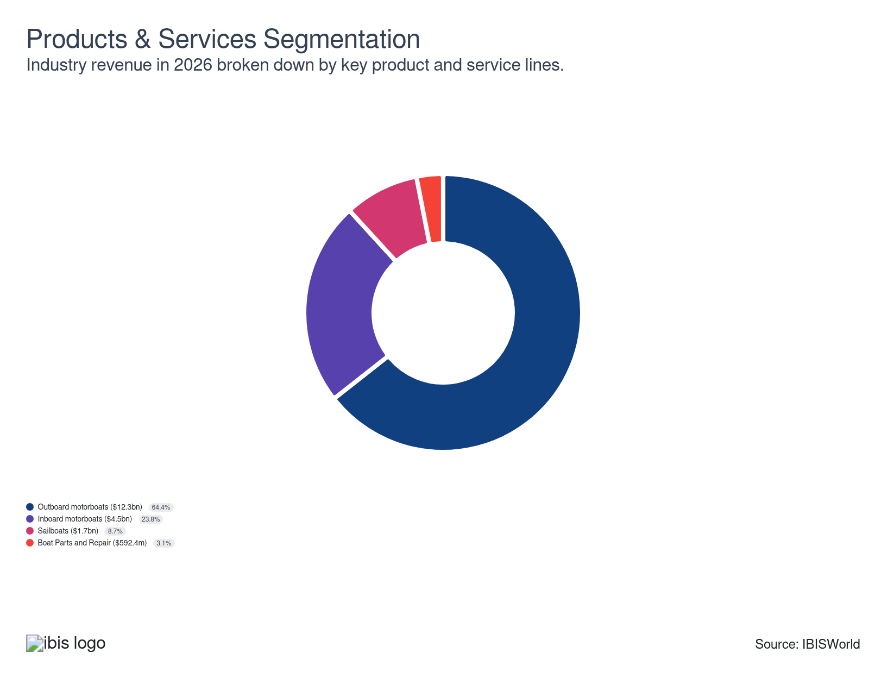

Major Players
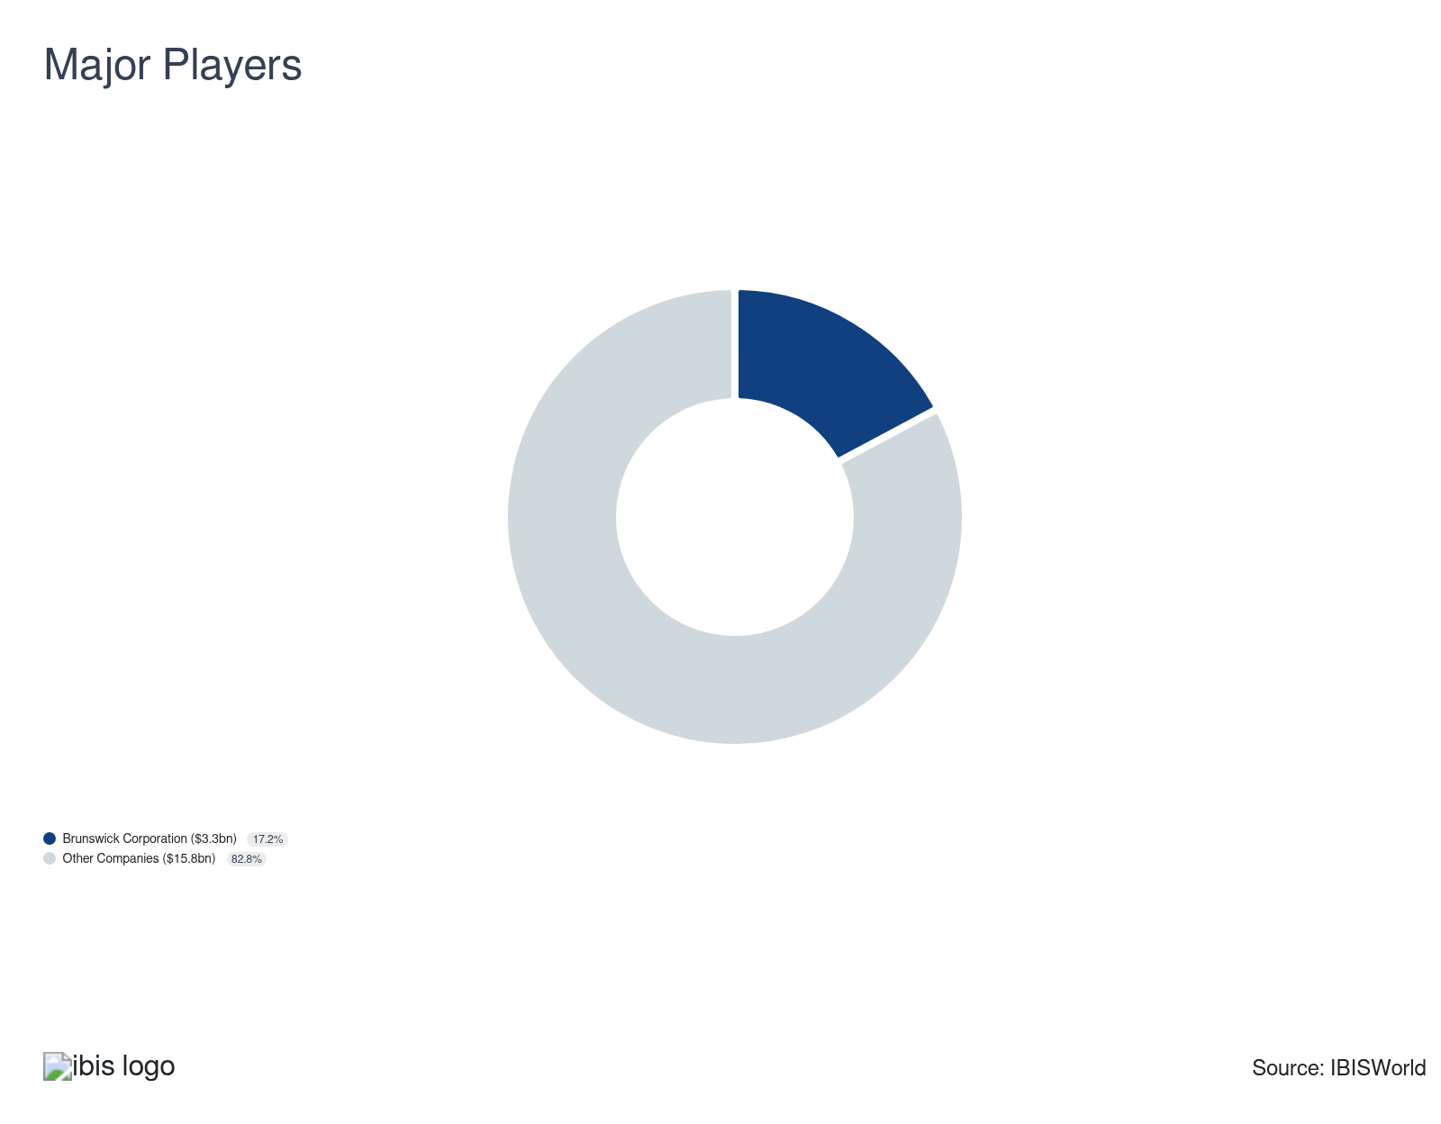

Key External Drivers
Key External Drivers | Impact
Per capita disposable income | Positive
Households earning more than $100,000 | Positive
Consumer confidence index | Positive
Producer Price Index: Plastic materials and resin | Positive
World price of aluminum | Positive

Industry Structure
Characteristic | Level | Trend
Concentration | Low
Barriers To Entry | Moderate | Increasing
Regulation and Policy | Moderate | Steady
Life Cycle | Mature
Revenue Volatility | Moderate
Assistance | Moderate | Steady
Competition | Moderate | Steady
Innovation | Moderate

SWOT
Strengths  Medium & Increasing Barriers to Entry  Medium Imports | Weaknesses  Low Profit vs. Sector Average  High Customer Class Concentration  High Product/Service Concentration  Low Revenue per Employee  High Capital Requirements | Opportunities  High Revenue Growth (2020-2025)  High Revenue Growth (2025-2030) | Threats  Low Revenue Growth (2005-2025)  Low Outlier Growth  Low Performance Drivers  Consumer confidence index

Executive Summary

Shipshape conditions: Rebounding consumer demand and confidence will support revenue growth
Boat builders manufacture various watercraft intended for personal, commercial and government use. These products are highly discretionary purchases, so boat builders rely on strong consumer confidence, disposable income and spending. Poor performance during the pandemic and amid high inflation have bracketed otherwise torrid expansion from boat builders. However, pent-up demand for travel and limited leisure options during the pandemic supported torrid growth in 2021 and 2022, leading to a massive influx of first-time buyers. This trend has altered the industry's structure, pushing companies to provide added value to convert first-timers into repeat customers, ensuring stable demand for parts and repairs. Even so, boat builders have endured volatile profit through the current period as supply chain disruptions prevented producers from properly allocating resources, leading to more sunk costs. Overall, revenue has expanded at an expected CAGR of 4.0% to $19.1 billion through the current period, despite a 0.5% decline in 2026, compounding a 0.8% decline the previous year. Profit has also settled at 0.9%.
Supply chain disruptions stemming from conflict in the Middle East and Russia and climbing import penetration have posed major threats to profitability. Metal, plastic, electronic components, lumber and oil prices ballooned, contributing to heightened purchase costs, longer lead times and bloated supply chains. While leading boat builders leveraged globalized supply chains and cemented reputations in key markets, many smaller companies were also unable to fully pass off the cost of more expensive inputs, creating volatility. Similarly, the trade-weighted index's appreciation has made imports less expensive in domestic markets, enabling boat and parts imports to satisfy a greater share of domestic demand. Tariffs will also play a major role in trade markets, potentially making domestic products more attractive but cutting into supply chains by reducing supply chain globalization.
Boat builders will benefit from the economy's recovery through the outlook period; stabilizing interest rates and generally improved consumer confidence will encourage individuals to travel more and take out loans to purchase boats, supporting consumer and commercial markets. However, the unknown economic impact of tariffs may decrease spending, counteracting growth due to lower interest rates. Long-term consumer preferences may also challenge revenue growth, as fewer Millennials have shown interest in boat ownership than previous generations; even so, rising wealth among this demographic may create new markets for boat builders. Additionally, stronger used boat markets may cause manufacturers to shift toward parts and add-on customization, rather than boats, especially expensive yachts and luxury vessels. Overall, revenue will strengthen at an expected CAGR of 0.8% to $19.9 billion through the outlook period, where profit will settle at 1.4%.

3. Performance
https://my.ibisworld.com/us/en/industry/33661b/performance

Highlights
Revenue  $19.1bn  2021-26 CAGR ↑ 4.0 %  2026-31 CAGR ↑ 0.8 % | Employees  39,276  2021-26 CAGR ↓ 0.5 %  2026-31 CAGR ↑ 0.6 % | Businesses  887  2021-26 CAGR ↑ 0.9 %  2026-31 CAGR ↑ 0.9 %
Profit  $172.0m  2021-26 CAGR ↓ 18.2 % | Profit Margin  0.9%  2021-26 CAGR ↓ 2.1 pp

Key Takeaways
- High interest rates have stymied boat-building demand through the latter half of the current period. Boats are a highly discretionary purchase, so skyrocketing interest rates have discouraged buyers from taking out loans to purchase boats.
- Innovation and customization will attract new commercial and consumer buyers. Companies will strive to cut costs with automation, while greater customization options, electric boats and autonomous features will encourage buyers to upgrade to new products.
- Defense markets will drive innovation in autonomous systems. Companies may look to partner with defense contractors and government agencies to secure novel contracts; however, the defense market is tightly contested, leaving few opportunities.
- Used boat sales have surged through the latter half of the current period. Increased used boat sales threaten boat builders, but potentially provide new opportunities for add-on sales and parts improvements.

Performance Snapshot
Revenue: | ↑ 2021-26 Revenue CAGR +4.0%
Revenue  $19.1bn  ’21-’26 ↑ 4.0 %  ’26-’31 ↑ 0.8 % | 2026 Revenue Growth  ↓ 0.5 % | Revenue Volatility  Moderate
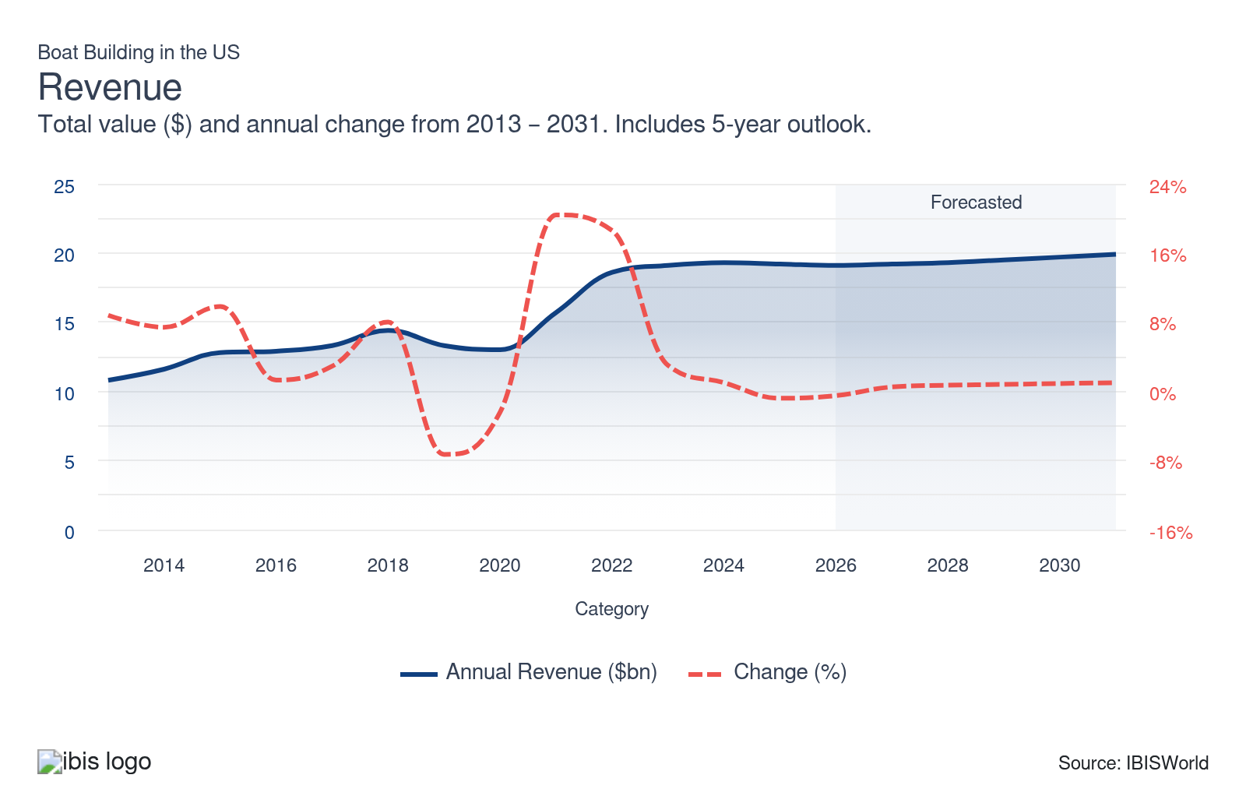
Employees: | ↓ 2021-26 Employees CAGR -0.5%
Employees  39,276  ’21-’26 ↓ 0.5 %  ’26-’31 ↑ 0.6 % | Employees per Business  44  ’21-’26 ↓ 1.4 %  ’26-’31 ↓ 0.3 % | Revenue per Employee  $487k  ’21-’26 ↑ 4.6 %  ’26-’31 ↑ 0.1 %
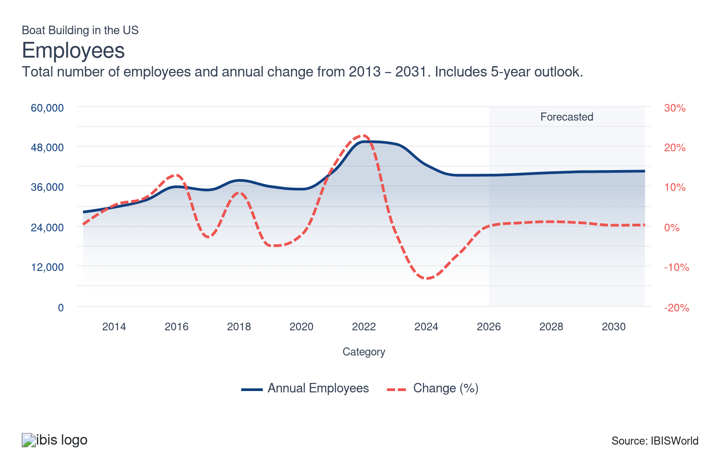
Businesses: | ↑ 2021-26 Business CAGR +0.9%
Businesses  887  ’21-’26 ↑ 0.9 %  ’26-’31 ↑ 0.9 % | Employees per Business  44  ’21-’26 ↓ 1.4 %  ’26-’31 ↓ 0.3 % | Revenue per Business  $21.5m  ’21-’26 ↑ 3.1 %  ’26-’31 ↓ 0.1 %
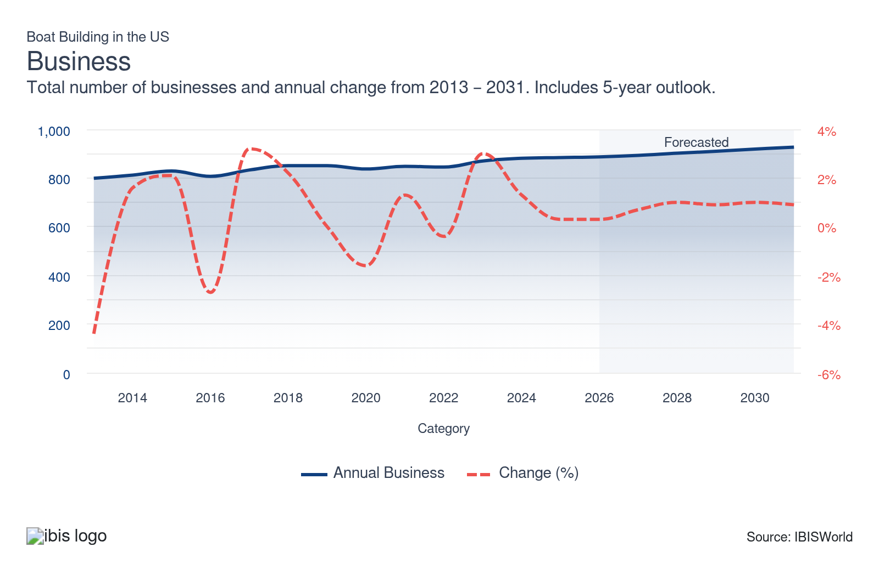
Profit: | ↓ 2021-26 Profit CAGR -18.2%
Total Profit  $172.0m  ’21-’26 ↓ 18.2 % | Profit Margin  0.9%  ’21-’26 ↓ 2.1 pp | Profit per Business  $193.9k
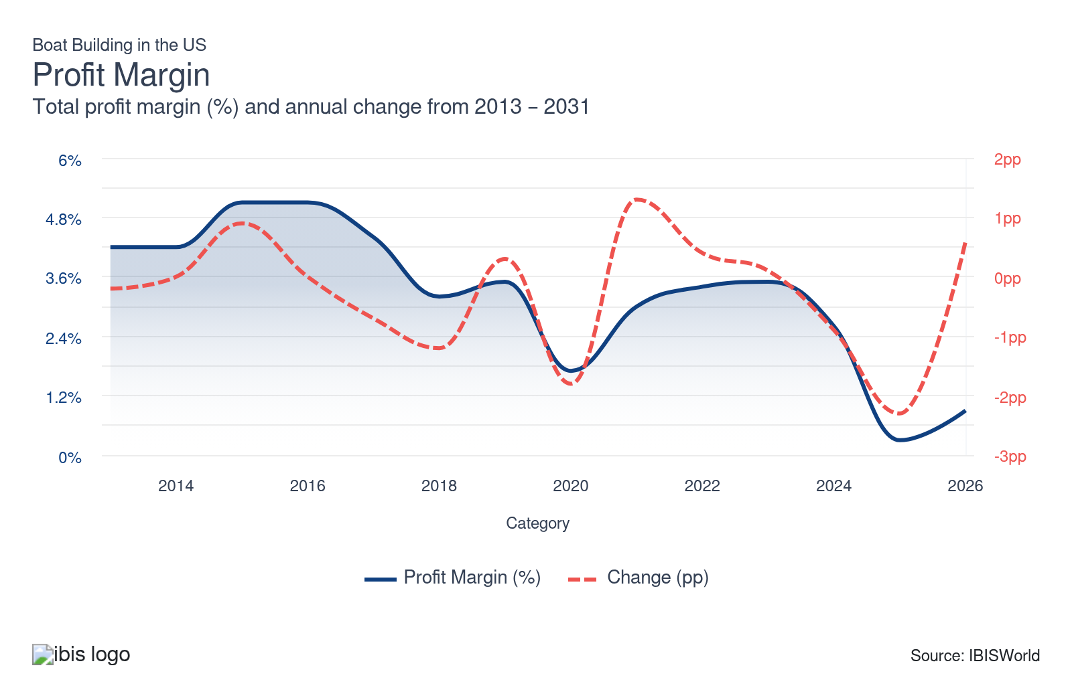
Current Performance
Current Performance

What's driving current industry performance?

The pandemic has created long-term changes to boating markets
- Lockdown restrictions amid the pandemic largely led to shifting leisure and entertainment consumption trends. Most companies in the hospitality sector closed or severely limited operations, as many countries enacted strict travel restrictions. These trends compelled consumers to select from a limited range of activities, often prioritizing outdoor pursuits to adhere to social distancing guidelines.
- As a result, private boating activities represented an outlet for many individuals seeking safe, outdoor activities. In fact, the National Marine Manufacturers Association states powerboat, sailboat and personal watercraft sales peaked in 2021 and 2022, contributing to a 20.4% and 18.6% revenue spike, respectively.
- While wealthier consumers tend to dominate private boat markets, sales to all demographics skyrocketed, creating demand for consumer markets alongside commercial rental and charter markets. While larger yachts, sport boats and sailboats remained costly and unattainable for lower and moderate-income consumers, baseline model fishing boats and unpowered boats have successfully infiltrated lower-income demographics because of the pandemic, creating a massive wave of first-time buyers and new revenue streams for boat manufacturers.
- Specifically, this trend immediately creates a more robust aftermarket, providing opportunities for parts production. In the long run, companies will need to provide added value in future products to ensure repeatable, sustainable sales and capture future boat purchases.
- As a result, companies may need to find new best practices to ensure first-time pandemic-era buyers convert into repeat customers. Companies can offer manufacturing warranties and other programs to build strong customer relationships, especially since many leading boat builders maintain ownership of boat dealers while smaller producers often sell directly to consumers. Similarly, companies have offered a wider host of customization options and iterative innovations, encouraging consumers and companies to purchase new boats more frequently and gain access to the latest technology.
- Altogether, these trends help companies develop stronger brand reputations, ensuring stable demand and entrenching products in key consumer markets. Regardless, demand for new boats is highly elastic among consumers, so faltering consumer confidence amid surging inflation, higher interest rates and global conflict may diminish demand and the industry’s long-term outlook regardless of action from the industry.

Volatile economic conditions hinder motorboat sales
- Economic uncertainty and high interest rates have bracketed strong pandemic-induced growth for boat builders. These trends have led to significant annual fluctuations, including notable revenue losses in 2025 and 2026. Exposed consumers have been reluctant to invest in premium products, instead opting for less expensive entertainment and leisure options. This shift has prompted some boat builders, particularly those with weaker reputations and smaller scopes, to rely on parts sales from the maintenance market.
- In general, sales volumes have flattened out as some buyers struggle to front the expensive loans, maintenance and fuel costs. As a result, smaller, less-known companies have struggled to freely pass costs onto buyers. However, higher-income buyers have displayed greater resistance to climbing interest rates and pervasive economic uncertainty.
- According to Boats Group, the less than 35-foot segment remains the most popular motorboat variety. Higher interest rates have also slammed luxury boat sales, with the total number and value of sailboats sold plummeting more than 13.7% and 10.2%, respectively, in 2025. In general, boats under 35 feet and nonmotorized boats have shown the greatest resilience; these cheaper options appeal to a wider consumer base and face fewer challenges amid economic instability.
- However, broader uncertainty has led to net declines across most motorboat segments, with the greatest losses in the 46’-55’ segment. Only the greater than 80-foot motorboat segment in North America saw real increases in all three categories: number of boats sold, value of boats sold and average boat value, through 2025. This suggests that companies may need to focus on these larger, more luxurious and custom-made offerings to stay afloat, relying on more economically agnostic customers as economic conditions price other buyers out of upgrades.
- Weaker economic conditions have also discouraged commercial buyers from upgrading vessel fleets, instead focusing on upgrades. However, demand for many boating activities has dropped, leading to less wear and tear on existing boats and limiting demand for parts from repair shops and businesses for end use. However, more essential industries, such as fishing, have driven commercial demand, even as charter rentals and other leisure boating industries cut costs.

Supply chain volatility limits profit growth
- Supply chain shocks from the pandemic, the Russian invasion of Ukraine and conflict in the Middle East have injected volatility into the industry, often limiting supply options and severely lengthening lead times. In general, the price of most key inputs, like plastic, lumber, electronics and metals, skyrocketed, forcing companies to reevaluate supply chains and procurement strategies while bloating cost structures and limiting profitability.
- Boat building supply chains are relatively inelastic, too. Companies have limited pricing power compared to massive suppliers of plastic, metal, lumber, and electronics, forcing producers to largely absorb cost increases. Growth in key producer price indices further reinforces the industry’s limited bargaining power, aside from a few multinational giants.
- Even so, many boat builders, especially luxury and vertically integrated builders, like Brunswick, with concrete brand reputations, were able to pass added costs onto buyers, mitigating losses during the period and contributing to solid revenue growth. Similarly, many companies leveraged globalized procurement strategies to supplement domestic supply chains with inexpensive foreign inputs, mitigating purchase cost volatility.
- Smaller boat builders still struggled with supply chain issues, lacking the capital flexibility and market presence to switch suppliers or pass additional costs onto buyers, causing overall profit to wilt. In general, unpredictable supply chains have forced companies to adapt new strategies. Boat builders can hold larger inventories as a buffer against future shortages, tying up valuable capital in inventory.
- Additionally, companies have considered potentially reshoring some operations or diversifying their supplier base to reduce dependency on distant or single sources. Reshoring may become an especially prominent factor as tariffs target many key international suppliers.

Boat builders have faced onerous trade markets
- Domestic boat builders navigate complex trade environments, with imports accounting for more than 10.0% of domestic demand. While the size, cost and complexity of boats make trade in high-end markets costly and unprofitable, some international conglomerates maintain significant domestic power. For example, Fincantieri Yachts, Lürssen and Group Beneteau have carved out strong niches in yacht markets, while multi-industry powerhouses, such as Yamaha, have developed overwhelming economies of scale and stellar reputations globally.
- As a result, motorboat and yacht manufacturers commonly face greater competition from manufacturers in France, Italy, the UK and the Netherlands. These markets have similar preferences and spending profiles, enabling foreign competitors to more easily sell in the United States with few product changes. As a result, Italian imports often rank first in domestic markets and create a generally disruptive force for domestic boatbuilders.
- On the other hand, companies contend with a wide range of low-cost exporters in more parts, generic boats and unmotorized watercraft markets. In these markets, Taiwan, Mexico and China are direct competitors. This behavior has encouraged many domestic companies to invest in higher-valued products rather than cut prices to compete in generic and parts markets. This strategy places greater emphasis on quality, added amenities and other various add-ons, helping boat builders generate stronger profit.
- Tariffs will place additional pressure on global markets. The new administration’s latest tariff proposals include duties on most trading partners, including EU countries and additional restrictions on Chinese goods. These policies will give domestic boat builders an additional advantage, especially those with largely domestic supply chains. These policies may also contribute to consolidation as domestic companies find greater success. However, tariffs risk unsettling global supply chains, creating unexpected input costs.
- Companies will need to weigh cost-cutting and automation strategies to secure greater economies of scale and profitability. Investment in automation, especially among leading boatyards, will become increasingly common as companies look to ensure global competitiveness. Companies may also continue to prioritize buyers in the South Pacific and Caribbean, diversifying revenue streams to reduce exposure to cyclical trends.

Used boat sales have surged, posing a threat to boat builders
- Surging used boat sales present unique challenges and opportunities for domestic boat builders, with Boats Group and the Marine Retailers Association (MRAA) reporting elevated used boat sales over the past few years. Both organizations highlight comparatively higher used boat turnover and lower used prices.
- Increased used boat sales and greater used boat stock are both functions of the post-pandemic sales spike. These figures, along with lower sales totals, suggest that first-time buyers have largely resold boat purchases. These trends also suggest that boat builders have been somewhat unsuccessful at converting first-time buyers into repeat customers, limiting opportunities for follow-on parts sales and potential future upselling into higher models.
- Even so, used boats are the main entry point into boating. Higher used inventories and lower prices show that some buyers clearly trade down from new to used when budgets tighten. For builders, that means fewer units shipped and weaker utilization of current production capacity. However, first-time owners can gain familiarity with a brand through used sales, ultimately driving future demand when they upgrade to new models.
- Additionally, a growing stock of used boats could improve the long-term installed marine base, which benefits OEMs with strong parts, accessories, engines and service networks. Owners of used boats frequently invest in repowers, electronics upgrades and refits, supporting engine brands, electronics packages and branded accessories tied to major builders. Builders that capture this lifecycle value can partially offset slower new-boat sales through recurring aftermarket and service revenue.

What influences industry volatility?

Boat builders have faced input volatility
- Boat builders have endured volatile input costs following major geopolitical events, including the pandemic, the Russian invasion of Ukraine, conflict in the Red Sea and shifting trade policies. In particular, steel, aluminum and plastic material prices spiked in 2021, contributing to profit declines. These additional costs have led to longer lead times and profit losses, forcing companies to reevaluate supply chains and adapt more proactive management systems.
- Even so, supply chain disruptions have eased through the latter half of the period, contributing to rebounding profit and lower volatility. Most companies successfully leveraged globalized supply chains, strong brand loyalty and dominant positions in niche markets to mitigate supply chain disruptions and pass added costs onto buyers.

Economic conditions drive revenue growth
- Boat builders heavily rely on consumer and commercial markets; positive economic conditions can encourage consumers to spend more on travel and luxury items, like boat purchases, rentals or watersports, supporting the industry's overall growth.
- Most notably, the pandemic limited demand in 2020; stay-at-home orders and poor consumer confidence contributed to weak demand and the subsequent 20.4% growth in 2021. Similarly, climbing interest rates have threatened growth in the latter half of the period. Manufacturers must ensure they develop resilient processes that avoid sunk costs when economic conditions sour.

Changing regulations can add to volatility
- Stricter environmental regulations can force builders to revamp designs and production processes, leading to increased costs and potential disruptions. Comparatively, new safety or quality regulations can increase time to market and operational costs, influencing pricing and profitability.
- As consumers and governments prioritize sustainability, shifts in demand toward greener products could catch unprepared companies off guard, affecting revenue unpredictably. Leading companies have the capacity to extensively invest in R&D, limiting the volatility associated with green regulations.

The Iran conflict has contributed to major volatility
- The ongoing conflict in Iran has presented major concerns for the industry's supply chains and domestic demand trends. On one end, supply chain disruptions have contributed to elevated prices, delays and shortages, forcing companies to absorb costs or pass them onto buyers.
- Additionally, higher gas prices and upfront costs have made owning and operating a motorboat less appealing, especially for middle and lower-income buyers. Lower boat usage slows replacement cycles and reduces revenue captured through demand for aftermarket and OEM-branded parts, limiting growth opportunities.
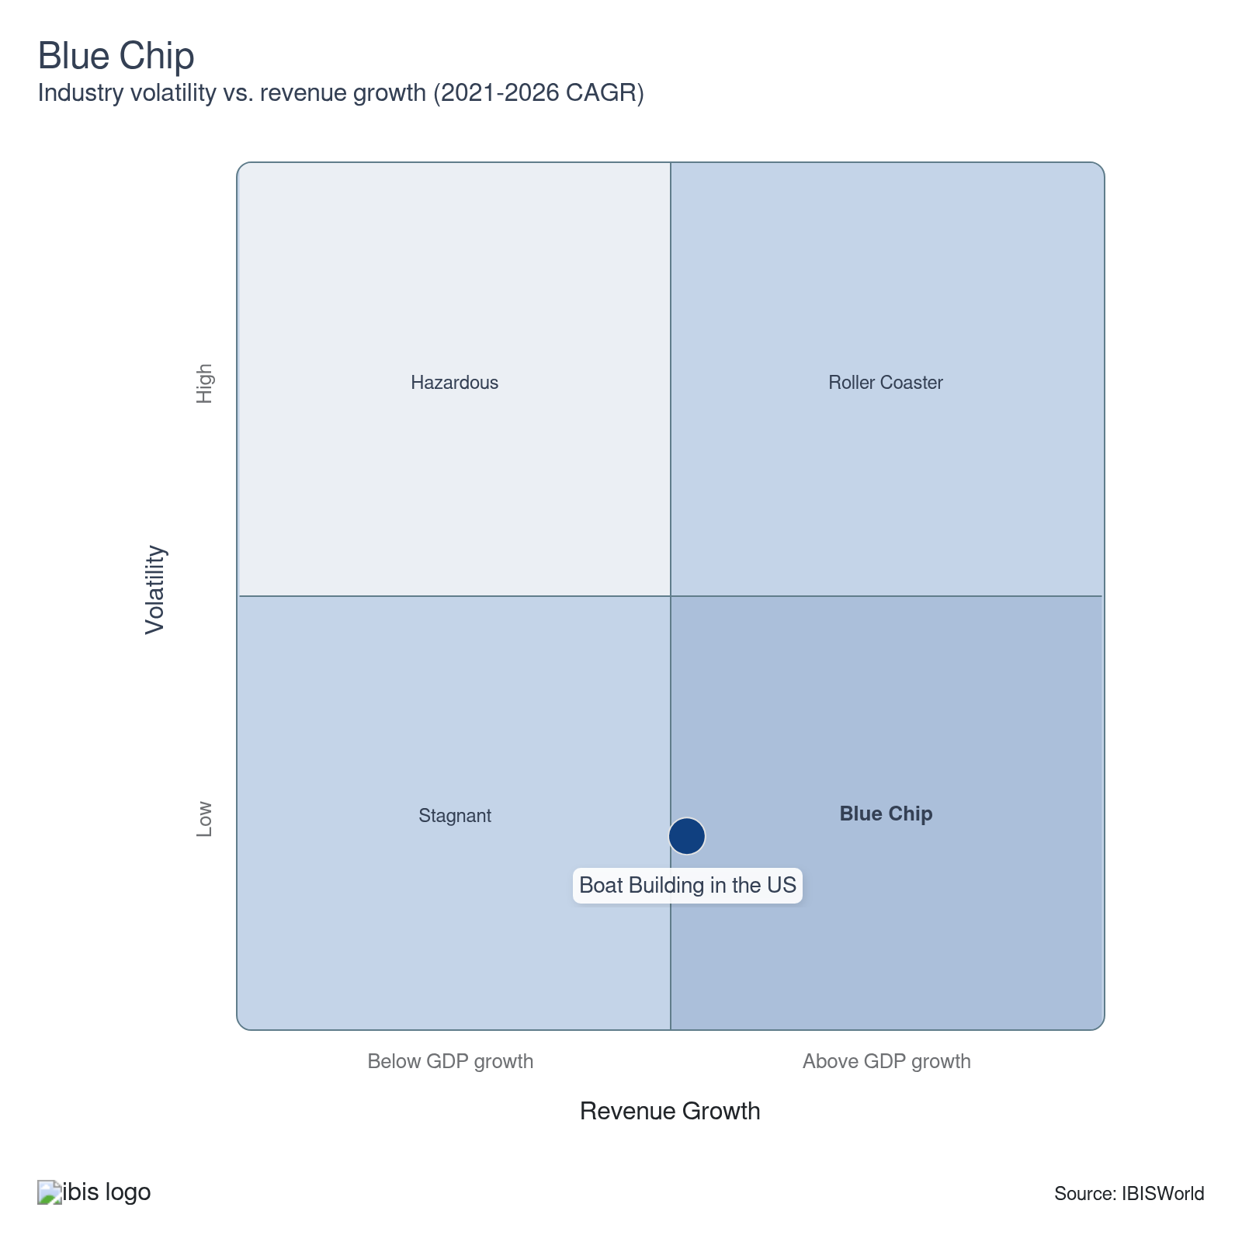

How do successful businesses overcome volatility?
Secure economies of scale
Operating within this industry requires a moderate level of capital investment. The ability to spread the fixed costs across a greater number of production units and achieve scale economies is important to competition within this industry.
Secure export markets
Larger boat builders in this industry have developed market penetration strategies. These strategies have been intended to grow and develop products and market opportunities overseas while mitigating volatility in domestic markets.
Outlook | ↑ 2026-31 Revenue CAGR +0.8%

What's driving the industry outlook?

The Iran conflict presents unique risks for boat builders
- Domestic boat builders will face significant pressure from the Iran conflict, impacting supply chains and demand trends, therefore introducing significant uncertainty into the market. Specifically, conflict and blockades in the Strait of Hormuz have caused massive price spikes and shipping delays, disrupting production schedules and threatening backlogs.
- Crude oil prices have skyrocketed, creating continued pressure on many key inputs, such as metal, plastics and electronics. Companies will face longer lead times, potentially eroding trust with large commercial buyers and dealer networks, therefore pressuring profitability.
- Higher oil prices will also contribute to significantly elevated fuel costs, making boat operation more expensive for most and untenable for others. Prolonged increases in fuel prices may lead to reduced boating activity, thereby weakening replacement and repair rates.
- While boat builders cannot avoid the macroeconomic shocks stemming from the Iran conflict, diversifying supply chains by qualifying additional suppliers and renegotiating contracts, combined with dynamic pricing and a focus on high-margin segments, can help mitigate exposure and reduce risk. However, the scope of these disruptions may constrain meaningful input substitution and materially limit the industry’s pricing power.

Greater customization options will support demand for boat builders
- Customization, particularly in high-end markets, is critical for continued sales and market development. Boat builders can offer a broad range of customizations aligned with consumer preferences. Manufacturers are likely to sustain sales by offering packages tailored to individual needs, driving stronger demand for custom-built boats and supporting a more favorable profit outlook. Many customization features also act as follow-on revenue streams, as consumers upgrade and modify their boats over their lifecycles.
- For example, boat builders can outfit advanced fishing boats with GPS, sonar systems, rod holders and other necessary items; similarly, boat builders can create luxury yachts with hot tubs, kitchens, showers and other luxury amenities to appeal to different demographics. This practice can help companies capitalize on greater demand for larger, costlier boats, as reported by Boats Group in 2025 (latest data available).
- These demand trends will support smaller, niche boat builders as consumers invest in higher-end products, enabling these companies to expand profit and invest in production to catch up to the industry’s leaders. However, leading boat builders with robust customization options, like Brunswick and Starcraft, will retain their major competitive advantages, flexing greater economies of scale, vertical integration and close relationships with independent dealers. On the other hand, lower consumer confidence from tariffs, the Iran conflict and higher interest rates may continue to mitigate growth opportunities.
- While consumer markets will remain the primary target of specialization options, commercial fishing markets will also remain a driving force in customization. For instance, larger fishing fleets will upgrade boats with better GPS, faster engines and better refrigeration technology. These options present significant upfront costs for commercial markets, especially smaller, independent buyers, but long-term profit potential. Similarly, leisure markets will demand greater access to electronics, comfort and amenities, like Wi-Fi, hot water, better cushioning, bars and other features.
- Boat builders will need to properly monitor market conditions to understand which customization options to invest in. For example, offering a wide range of leisure-based customization options would perform poorly in regions where fishing activity is the primary driver of boating demand, like New England. Proper market research will remain essential, helping boat builders accurately assess regional demand trends while limiting sunk costs associated with improper resource allocation.

Companies have integrated new manufacturing technologies and practices
- Many boat builders have adopted new technology to improve internal efficiency and appeal to a wider range of buyers. In particular, leading producers have adopted internal automation to eliminate assembly positions and save on wage expenses. This practice can also enable boat builders to reallocate wage expenses toward skilled labor, investing more in boat safety, sustainability, comfort and utility. These focuses will help companies boost brand reputations and create more resilient demand.
- In particular, many boat builders have started to adopt computer-aided design (CAD) programs and artificial intelligence alongside artificial and virtual reality programs to streamline research, development and design functions. These programs can help companies maintain leaner supply chains and enable builders to test designs virtually before physical production, reducing errors and material waste while significantly lifting quality and precision.
- Larger boat builders and shipyards will have a significantly easier time investing in, adopting and integrating these technologies into daily processes and workflows. These companies often have more robust cash flows and investment capacities compared with smaller builders. Additionally, larger-scale operations realize stronger returns from automation and artificial intelligence.
- In comparison, small builders often focus on bespoke, handcrafted boats, where the benefits of automated design and production are less pronounced. Their lower production volumes don’t necessitate the large-scale efficiencies CAD and AI provide. Companies will need to closely evaluate production scales and long-term goals, traversing either greater labor or automation investment.

Boat builders rapidly invest in electrification to meet shifting preferences
- Boat builders have prioritized innovations that improve function and fuel efficiency, especially as fuel costs rise. Most commonly, boat builders have integrated newer, lightweight materials into designs, reducing weights without compromising hull strength and durability. Advanced composites, like carbon fiber and fiberglass, provide the greatest opportunity. These composites also have greater corrosion resistance, improving boat longevity, which appeals to a wider range of buyers.
- Some boat builders have also specialized in electric-powered boats, but costs remain prohibitively high for most potential buyers. Most notably, Brunswick has launched a lower-cost electric boat under the Veer brand. The company’s foray into electrification will likely push other smaller competitors to follow, thereby hastening e-mobility trends in boats.
- The company hopes to tap into lower-cost markets for electric boats, representing a major untapped market. For instance, Boatline and the Marine Retailers Association report that 72.0% of prospective boat buyers are interested in electric boats, with 39.0% stating exclusive interest in electric boats.
- Regardless, the market is actively favoring low and zero-emission alternatives, with increasingly strict regulations expected over the next decade. Specifically, tightening emissions and noise rules on lakes, rivers and urban waterways will steadily favor zero- and low-emission boats, creating a structural demand tailwind for electric platforms and potentially giving builders a path into premium, “permission-constrained” niches.
- Companies will need to invest in these platforms to find continued success, with opportunities to garner significant first and early-mover advantages in both commercial and government markets. Companies can highlight total-cost-of-ownership propositions that can justify higher upfront prices and subscription models. In general, rapid improvements in batteries, power electronics and hybrid systems will allow builders to extend electrification from small day boats into larger yachts, ferries, workboats and patrol craft, expanding their addressable market.

Companies have worked toward autonomous boating technologies, particularly in the defense network
- Autonomous and semi-autonomous boating is also on the horizon for boat builders. For example, semi-autonomous technologies, including advanced autopilot systems, collision avoidance and automated docking, are becoming more common but remain unviable or even outright banned in crowded ports and marinas.
- Autonomous systems can enhance safety by reducing human error, automating collision avoidance and ensuring optimized navigation. The ability for boats to operate autonomously opens up new markets and applications, such as unmanned cargo deliveries, autonomous ferries, research vessels and leisure craft for those who prefer not to pilot a boat themselves. These innovations will make boating more accessible across commercial and consumer markets, boosting the overall market outlook.
- Autonomous technology has become especially prominent in the defense market, with the Department of Defense offering contracts for numerous small and mid-size unmanned and semi-unmanned landing craft and other vessels. Current contracts include the MUSV, LUSV, USV family of systems and Saronic autonomous surface vessels, among others. These contracts are closely kept by leading naval and electronics defense contractors, severely limiting potential market entry.
- However, an uncertain economic future may pause aggressive R&D research. Volatility surrounding tariffs may ripple through supply chains, limiting consumer spending. These restrictions will especially limit innovation from smaller builders that lack more robust cash flows, while larger companies use capital surpluses to gain a competitive advantage. Companies will need to practice acute capital management to ensure products remain competitive.

Defense markets will remain crucial for some builders
- While government and defense markets make up a relatively small portion of revenue, given the US Navy’s preference toward larger ships, like destroyers and carriers, these buyers represent a key facet of the industry’s overall landscape. The unique operational scale of government buyers alongside complex bidding, accreditation and security clearance processes often encourages boat builders to specialize in government contracting.
- Regardless, climbing world tensions due to major conflicts in the Middle East and Eastern Europe, alongside high tensions regarding the South China Sea and Taiwan, will create significantly elevated demand from various coast guard services and US allies with smaller-scale navies and greater emphasis on local patrol. As a result, exports to various US allies and beneficiaries will increase. For example, Saudi Arabia has historically been among the leading customers of US foreign military sales, with boat sales skyrocketing through much of the current period.
- While the Saudis have increasingly emphasized internal production, the country’s government will continue to rely on the US and NATO to supplement fleets and avoid piracy. Other nations, like Israel, Oman, India, Turkey and the UAE, will likely also continue to display elevated purchasing trends, particularly for landing craft and patrol vessels, as the Iran conflict persists . The US government also has a vested interest in the region to protect Red Sea shipping lanes and often facilitates the sale of patrol motorboats through various contractors.
- Even so, commercial boat sales eclipse defense demand internationally. The largest buyers of domestic boats will remain major tourist destinations, such as the Bahamas, the Cayman Islands, Costa Rica and other similar Caribbean islands. These countries record significantly higher import volumes of motorboats and other personal watercraft than of most other goods and services, highlighting the region’s reliance on water-based activities and tourism. The high quality of US-made products will continue to appeal to luxury tourism services in these regions, contributing to steady exports through the outlook period.
Life Cycle | Mature

Why is the industry mature?

Contribution to GDP
Boat builders steadily contribute to the US economy. Domestic manufacturers benefit from widespread market acceptance, well-established markets and stable growth. The industry's longevity, well-defined products and stability are also clear signs of a highly mature market. However, limited regionality can reduce growth opportunities.

Market Saturation
Boat builders often operate in specific niches, offering custom-built products for a wide range of clients. Saturation often varies significantly by market niche; generally, standardized and generic boats and parts manufacturers face greater competition from domestic and international producers. Saturation also varies heavily by region, with coastal areas facing greater competition compared with small boat builders near smaller waterways.

Innovation
Boat builders have focused primarily on building small, value-priced boats with small engines to meet consumer demand for greater fuel efficiency. In particular, builders have incorporated lighter materials with greater resistance to rust and corrosion. Companies have also made strides in electrification and autonomous guidance though these boats remain prohibitively costly for most buyers.

Consolidation
Boat builders regularly consolidate to cut costs and improve operational capacity. Larger companies regularly target competitors with strong product portfolios and innovation teams, as well as companies with access to less saturated, profitable markets or untapped regions. Leading boat builders have multiple brands in their portfolios.

Technology & Systems
Manufacturers have prioritized production efficiency and improving the quality of life of high-end products. For example, many companies have started to integrate computer design systems and automation. Companies must integrate various computer systems to aid in designing and testing boats.

4. Products and Markets
https://my.ibisworld.com/us/en/industry/33661b/products-and-markets
Largest Market  $12.3bn  Outboard motorboats | Product Innovation  Moderate

Key Takeaways
- Outboard motorboats continue to be the most popular product. Outboard motorboats are consistently more affordable than other motorized boats and are extremely versatile across all key markets.
- Individual consumers remain the largest downstream market. Wealthy consumers make up the vast majority of demand in the consumer segment. As a result, sales of larger boats have performed better than alternatives.
- Boat builders may face higher input costs as tariff proposals take effect. Companies may also face reduced pressure from a wide range of foreign competitors, potentially enabling builders to capture a greater share of domestic demand from imports.

Products and Services
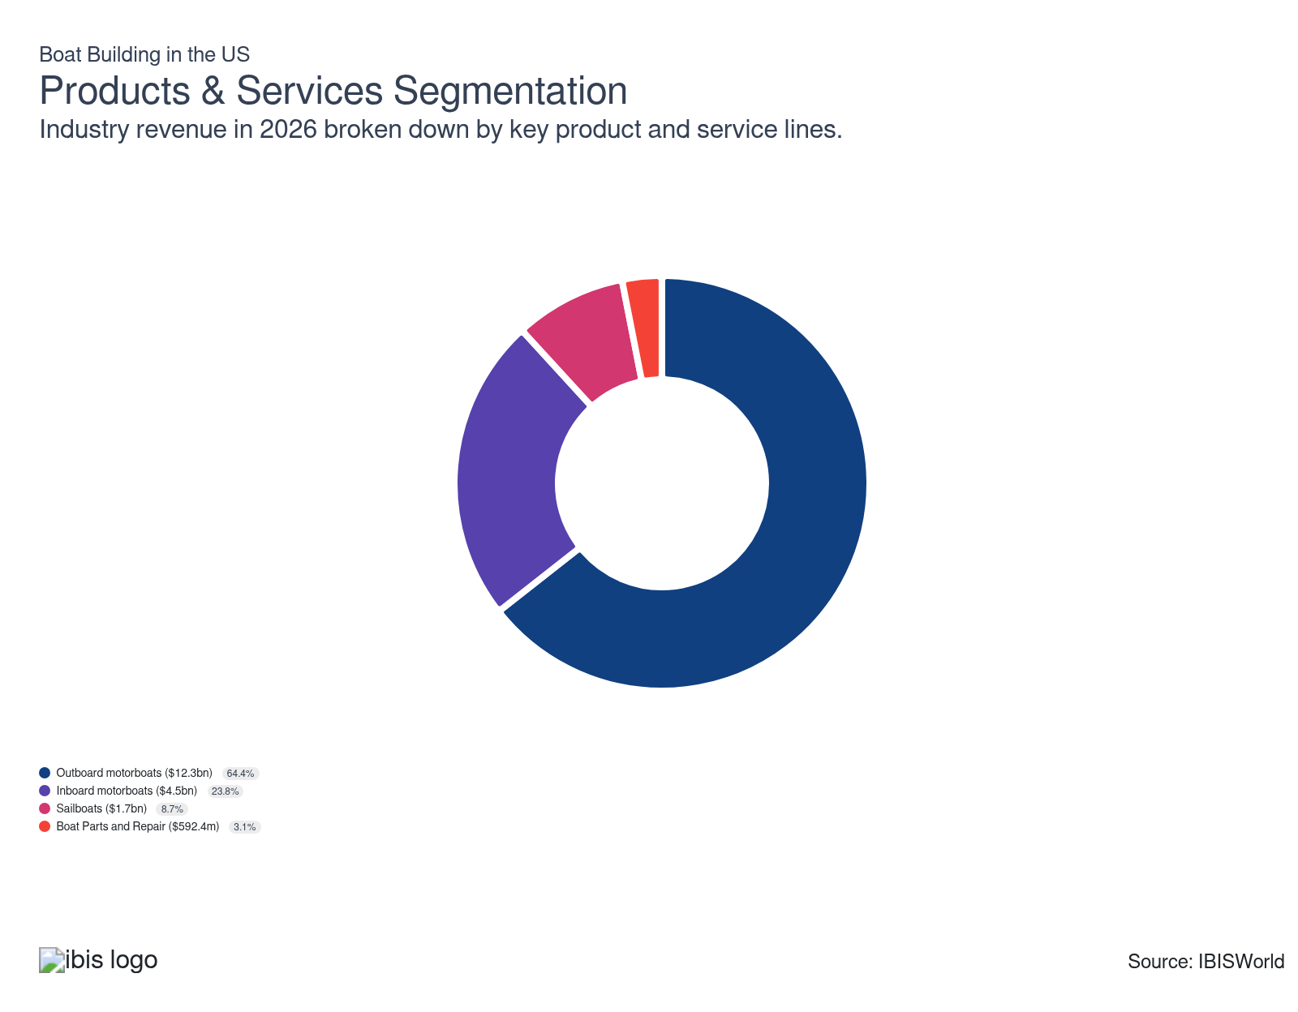

How are the industry’s products and services performing?

Outboard motorboats are the bestselling product
- An outboard motorboat is a small to medium-sized boat powered by a self-contained detachable engine and propulsion system attached to the transom. This category includes runabouts, bass boats, utility boats and offshore fishing boats. Outboards are popular since the engine is easily accessible and can be tilted completely out of the water when not in use due to its mounting position high up on the transom.
- Boat builders manufacture most outboard motorboats for commercial use. These products are also more standardized, leading to heavier competition and limited differentiation. Many builders rely on enhanced safety features and competitive pricing to make these products attractive; however, companies have increasingly leaned into customization, creating boats tailored to fishing, leisure, coast guard work and other niches.
- Outboard motors are competitively priced and offer easy control, maintenance and replacement. Demand for this product has increased, especially amid the pandemic. Many wealthier consumers purchased boats to spend leisure time during lockdowns, boosting demand for outboard and inboard motorboats. Boat sales have weakened, according to the 2025 Boats Group report, with smaller boats accruing less value per sale and overall sale volumes declining. Used boat availability and high operational costs have played major roles in declining sales.

Inboard motorboats are a growing product segment
- Inboard motorboats are mid-sized to large boats powered by an attached engine located inside the hull, normally in the middle or front of the boat, with a prop shaft running through the bottom of the boat. Inboard motors offer great stability and are well-suited to commercial, offshore and certain water skiing activities. Most of these boats are cabin cruisers and sports boats.
- Inboard motorboats account for a small share of unit volume but generate extremely strong per-unit revenue because of high upfront costs. These boats have marginally increased as a share of revenue as more people take private cruises and liveaboard vacations, requiring travel companies to upgrade boat fleets. In fact, Boats Group reported that the 80ft+ segment was the only to display positive growth by sales value and volume over the past three years.

Sailboats represent a unique, luxury niche for boat builders
- Sailboats represent a unique opportunity for boat builders. These products rely more consistently on custom designs and manual labor, preventing large-scale and foreign builders from seizing demand. Instead, buyers rely on more bespoke builders with strong reputations to fulfill demand.
- Given the labor requirements, this segment often generates the highest per-unit revenues. At the same time, upfront costs present a major limiting factor, causing sailboat sales to represent a minor share of total revenue and volume. However, companies operating through this segment often enjoy greater entrenchment and visibility than other brands, with the exception of Brunswick.

Boat parts and repair services experience consistent demand
- Boat parts and repair services are the smallest product segment. Modern boats use many mechanical parts and require regular servicing. Personalized watercraft often require specialized maintenance. These services generate additional revenue for manufacturers, but most repair and maintenance services occur at the dealer level.
- Inboard-outdrive systems have more fragile motors than outboard counterparts and require complicated maintenance. This provides the industry with a consistent revenue stream. Repair will remain a consistent, but minor portion of demand for repairs and parts.
- Some companies have prioritized this niche, solely manufacturing boat engines, parts and other marine equipment. These companies can become key tier 2 suppliers and avoid competition from Brunswick and other larger boat manufacturers.

What are innovations in industry products and services?

Boat builders prioritize production efficiencies
- Commercial and governmental contracts often require bulk production. Boat builders have focused on streamlining production to capitalize on economy of scale. Builders have tried a variety of methods, to varying degrees of success, to cut down production time and per-unit material costs.
- Many companies have automated production and integrated computer design systems to improve design. New artificial and virtual reality systems enable boat builders to visualize and test designs without spending to develop physical concepts and prototypes.

Buyers increasingly want personalized products
- Increased demand for made-to-order boats has driven front-end innovations within boat building. Boat builders have added more advanced navigation systems and better onboard amenities to attract customers. Some boat manufacturers have also added sonar and GPS systems to help fishermen map ocean floors.
- Some companies have even started developing electric-powered boats, but the prices significantly eclipse traditional boats. This innovation will hinge on the successful integration of batteries and electric charging capabilities, creating unique niche opportunities for innovative boat builders.

Boat builders improve boat desigsn and technological capabilities
- Advanced composites like carbon fiber and fiberglass are transforming hull construction, offering greater strength without added weight. The reduced weight of composite materials leads to better fuel efficiency, a critical consideration in both commercial and recreational boating. Composites provide superior resistance to corrosion compared to traditional materials, increasing the lifespan of vessels and reducing maintenance costs.
- Automation and smart technology now enable seamless integration of navigation, engine management, and communication systems, simplifying operations for users. Innovations like automated collision avoidance systems and remote monitoring enhance safety and provide peace of mind for boaters. Intuitive touchscreen controls and smartphone connectivity make advanced technology accessible, attracting tech-savvy consumers and improving user experience.

What products or services do successful businesses offer?
Be an early adopter of new technologies
Boat building requires manufacturers to be well-informed about the latest technological advances, and technical and performance characteristics.
Undertake technical research and development
Boat builders that target high-end clientele are increasingly using rare and innovative inputs to differentiate from competitors and charge a price premium.

Major Markets
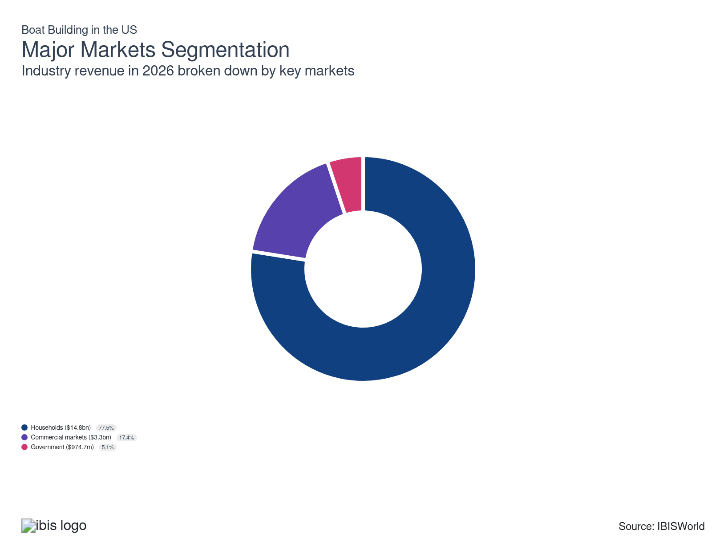

What’s influencing demand from the industry’s markets?

Most buyers are individual consumers and households
- Households for personal and leisure use generate the largest revenue for boat builders. Due to a relative lack of time and income, very few luxury boat owners are younger than 45, with boat ownership being particularly uncommon among Millennials. However, the oldest Millennials are about 40 years old, which means many boat manufacturers are confident that these consumers will soon enter the prime age group for boat-buying, translating to a bump in revenue.
- With an average income of more than $85,000, people between the ages of 45 and 64 are in the strongest financial position to continue patronizing boat builders. Depending on the type of boat, the average age of buyers of new recreational boats is between 51 and 56.
- Demand from individual consumers is particularly robust among high-income households. Many people purchased boats amid lockdown restrictions; these restrictive measures combined with added leisure time created heightened demand for boats and limited demand for other recreational activity, translating to strong revenue growth.
- However, higher interest rates, eroding consumer confidence and higher boat costs have created uncertainty among households, especially middle-ground markets. Smaller motorized boat sales have fallen consistently through the current period, with luxury purchases (greater than 56') largely propping up growth in terms of volume and value of new boats sold. Used boats have also posed a threat to this market's development.

Commercial markets experience volatile conditions
- Commercial markets commonly include leisure and fishing operations, like charter boats, liveaboard vacations and smaller-scale commercial fishing. Demand for commercial boats faltered in the early 2020; economic uncertainty made businesses less likely to upgrade vessel fleets; conversely, demand for leisure-related commercial charters surged in 2021 and 2022, creating uneven growth. Higher rates may also prevent investment in new boats, with commercial buyers preferring repair markets and used boats.
- Demand for many of these services depends on consumer spending patterns and disposable income. Revenue from this market is highly volatile; even so, pent-up demand for travel has supported commercial markets amid volatile consumer confidence and spiking interest rates in the near term. Steadier demand from non-leisure activities will drive revenue through the outlook period.
- Conversely, fishermen and other non-consumer-facing boating industries will upgrade boat fleets when corporate profit improves. Acquisition rates in fishing industries will also depend on the fishing season, climate or weather conditions. Companies can develop relationships with major commercial buyers, creating stronger revenue streams and potentially limiting the risk of buyers switching to other brands.

Government demand is minimal but consistent
- Multiple military branches and public sector buyers purchase boats and parts for operation. The Navy often contracts smaller landing craft and patrol boats, while the National Park Service purchases multiple boats for security. The US Coast Guard is another major buyer of smaller boats and craft. Increased naval spending on autonomous surface boats may bolster long-term spending in this segment.
- Although the government market is the smallest, it's also the most stable. Government agencies regularly increase spending budgets leading to consistent opportunities for boat builders. The defense markets operate separately from commercial and consumer markets, with companies bidding to complete contracts for the lowest possible price. The defense market for boats is significantly smaller than that for shipbuilding.

International Trade
Total Imports  $2.1bn  ’21-’26 ↓ 4.0 %  ’26-’31 ↑ 0.9 % | Total Exports  $1.4bn  ’21-’26 ↓ 0.8 %  ’26-’31 ↑ 0.7 % | Trade Balance  Net Importer  ↓ Deficit: $-657.3m

International Trade Imports
International Trade Imports
International Trade Exports
International Trade Exports
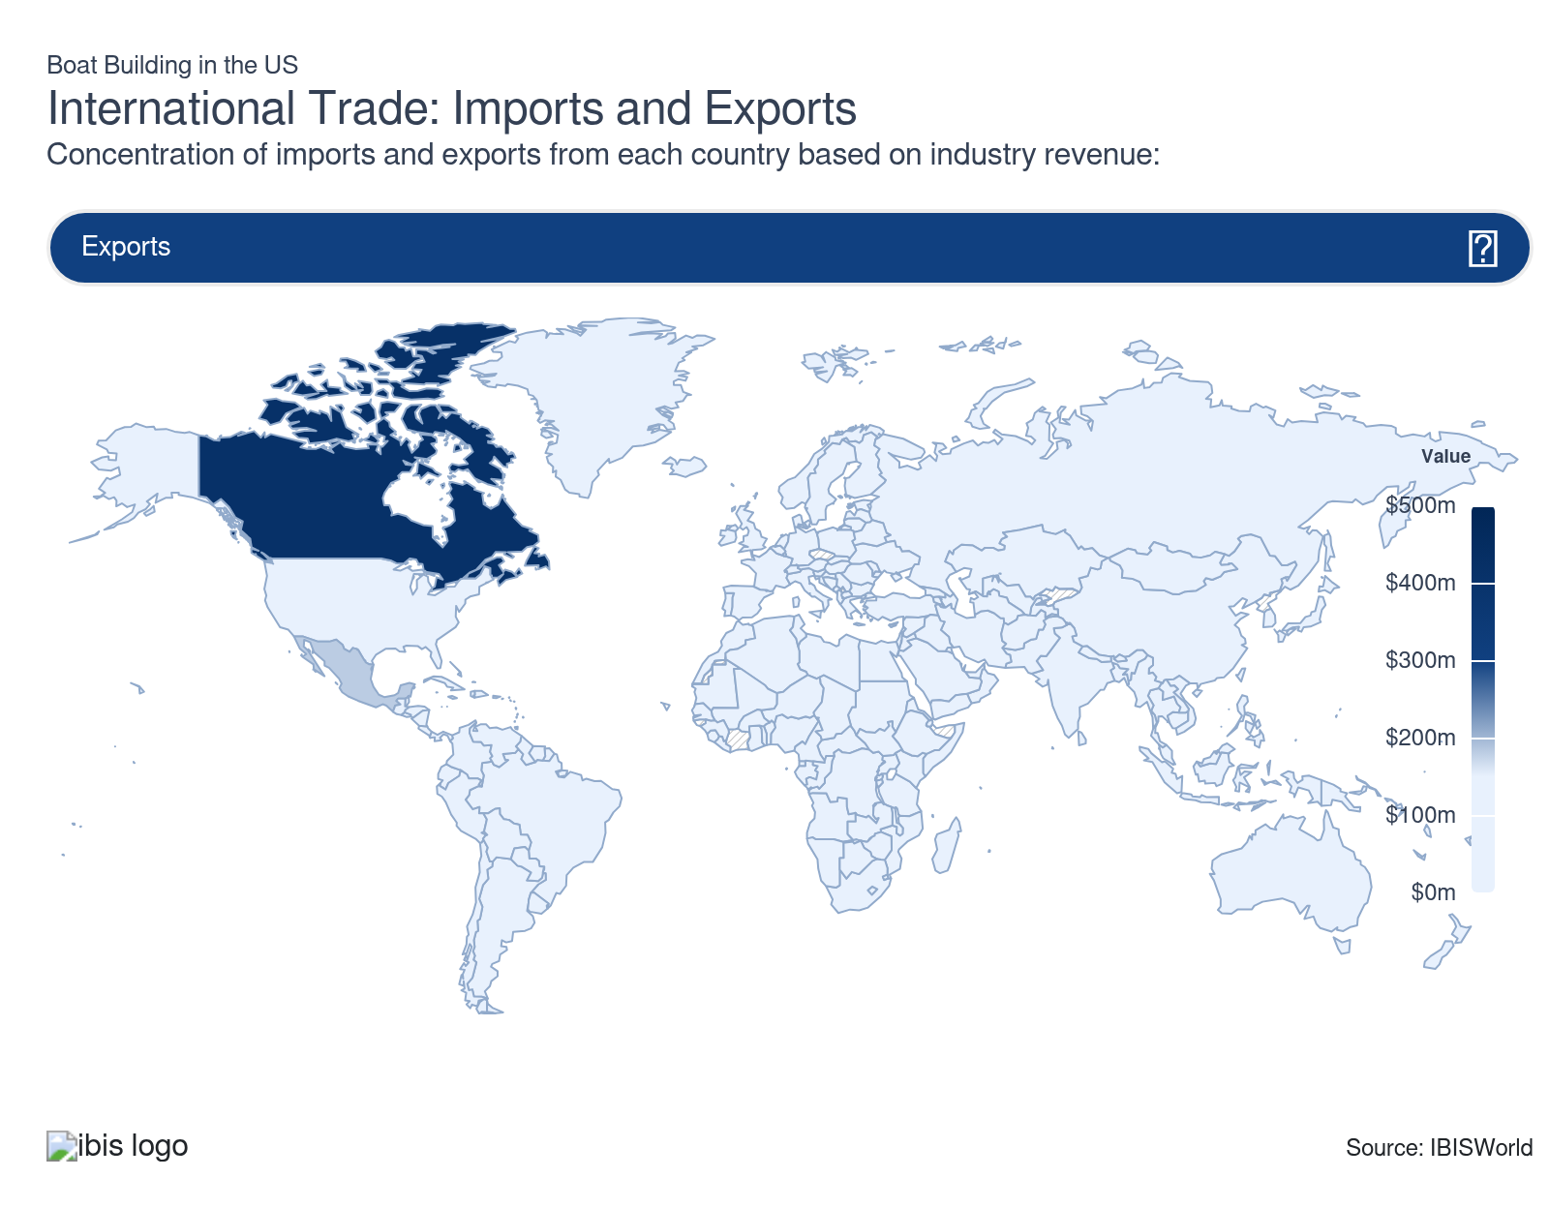

Imports
Moderate | Decreasing

What are the industry’s import trends?

Italy and France dominate trade markets
- Italy and France have historically accounted for more than one-third of total imports, though France's contribution has sharply fallen through 2024 and 2025, with minor YTD increases through 2026. Many luxury brands have headquarters and major operations in these regions since Italy and France are popular coastal tourism destinations.
- Many high-income buyers prefer Italian and French brands compared with US luxury boats, given the strong name recognition of Fincanteri and other European brands; the dollar's appreciation has also made foreign boats and parts more affordable for domestic buyers. In particular, buyers may choose foreign brands for larger sporting and leisure vessels, while US brands, like Boston Whaler, hold stronger positions among smaller boat or fishing markets.
- Other common trading partners, like the United Kingdom and Canada, are major importers, offering quality similar to that of popular US, French and Italian brands. Even so, these groups often lack the reputation to directly compete with the industry's powerhouses.

Low-cost importers hold key positions
- Taiwan and China also remain popular exporters of boats and related parts, often leveraging their strong economies of scale and cost-effective manufacturing practices to produce parts and generic boats competitively. In China and Mexico, companies have also leveraged lax regulations to cost cut.
- The industry often struggles to match the sheer scale and pricing capabilities of these imports, ceding the lower end of the market to competitors. Instead, the industry has increasingly focused on value-added products, such as advanced propulsion or luxury vessels, to ensure market dominance.
- Additionally, the presence of new tariffs starting in 2025 may severely limit import penetration. US-assembled boats generally have a high percentage of entirely US-made content, which would make the industry more resilient to the impact of tariffs.

Tariff policies and trade negotiations have created some unique global conditions
- The Trump Administration has levied several blanket and product-specific tariffs, particularly on boat parts, engines and other propulsion systems. These duties have had a tangible impact, with imports declining more than 4.0% through the current period, including 34.0% in 2025 and an expected 2.2% in 2026.
- Other factors, including eroding consumer confidence and increased used-boat sales, have also contributed to lower import volumes. Regardless, imports have satisfied a lower share of domestic demand in the past two years, suggesting some degree of efficacy from tariffs.
- However, these policies have also targeted several key inputs for boat builders, ranging from metals, plastics and lumber to electronics and other advanced navigational equipment. These tariffs risk raising costs across the supply chain, forcing builders to raise prices and ultimately deterring consumer and commercial demand.

Exports
Moderate | Decreasing

What are the industry’s export trends?

Companies have increasingly leveraged exports to popular tourist destinations
- Exports skyrocketed through most of the current period, especially following the pandemic in 2021. Consumers have expressed pent-up demand for travel and leisure, with many displaying preferences for watersports and warm regions. This trend has caused tourism companies to more aggressively invest in new boats for charters, rentals and tours in popular tourist destinations.
- In particular, exports to Costa Rica skyrocketed in 2023. The region boasts numerous coastal tourism attractions, resulting in high demand. Other popular tourist destinations, like Spain, the Cayman Islands and the Bahamas, also make up notable export destinations.
- Demand from these smaller, tourist-driven locations can heavily fluctuate from year to year, with purchases displaying high cyclicality every few years. US boat builders can often predict these fluctuations, maintaining healthy backlogs and ensuring stable revenue from exports.

The United States-Mexico-Canada Agreement (USMCA) supports growth
- Due to the USMCA and the proximity to domestic manufacturers, Canada and Mexico are the two most prominent destinations for exports. In fact, the two countries often represent more than half of all domestic exports; however, significant export declines to Canada have weighed on this revenue source.
- Domestic boat builders have taken advantage of well-established trade routes and favorable policies to cut transportation and import duty costs, creating steady growth in export markets. However, tariffs and the potential for renewed retaliatory actions may shift export markets, encouraging these foreign nations to prefer other boat builders, such as those in Brazil, Italy or Spain.
- Additionally, the end of the USMCA trade agreement and the potential for renegotiation create some major export uncertainty. Companies may prioritize export market diversification, reducing their reliance on trade agreements with Canada and Mexico and leaning into demand from popular tourist destinations.

Certain countries exhibit massive single-year swings
- Many popular tourist destinations, like the Bahamas, Cayman Islands and Costa Rica, exhibit massive single-year intakes followed by periods of limited purchases, supporting growth but inducing volatility. These trends often correlate to increases in tourism, weather patterns and aging vehicle fleets, leading to significant bulk buying habits.
- For example, Costa Rican exports increased nearly 1000.0% in 2023, while sales to the Bahamas increased more than 750.0% through 2024, reaching decade-highs. Intake from many of these smaller Caribbean nations has proven cyclical, with similar spikes occurring across most of the current period, especially following the end of global travel restrictions.
- Even so, these countries make up a relatively small share of demand for boat builders, primarily for luxury boats. Companies, like Brunswick, typically dominate these niches, leaving little room for other competitors to capitalize. These markets will likely remain unpredictable, displaying cyclical growth.

5. Geographic Breakdown
https://my.ibisworld.com/us/en/industry/33661b/geographic-breakdown

Key Takeaways
- Most manufacturers operate close to coastal regions. Most boat builders have operations in the Southeast, Great Lakes and West regions. These regions can display varying demand with the Southeast and West relying more heavily on tourism while other regions may prioritize fishing.
- The West has accounted for an increasing share of business locations. California, in particular, is popular for boat builders due to its proximity to major trading partners, affluent population and strong labor market.

Business Locations
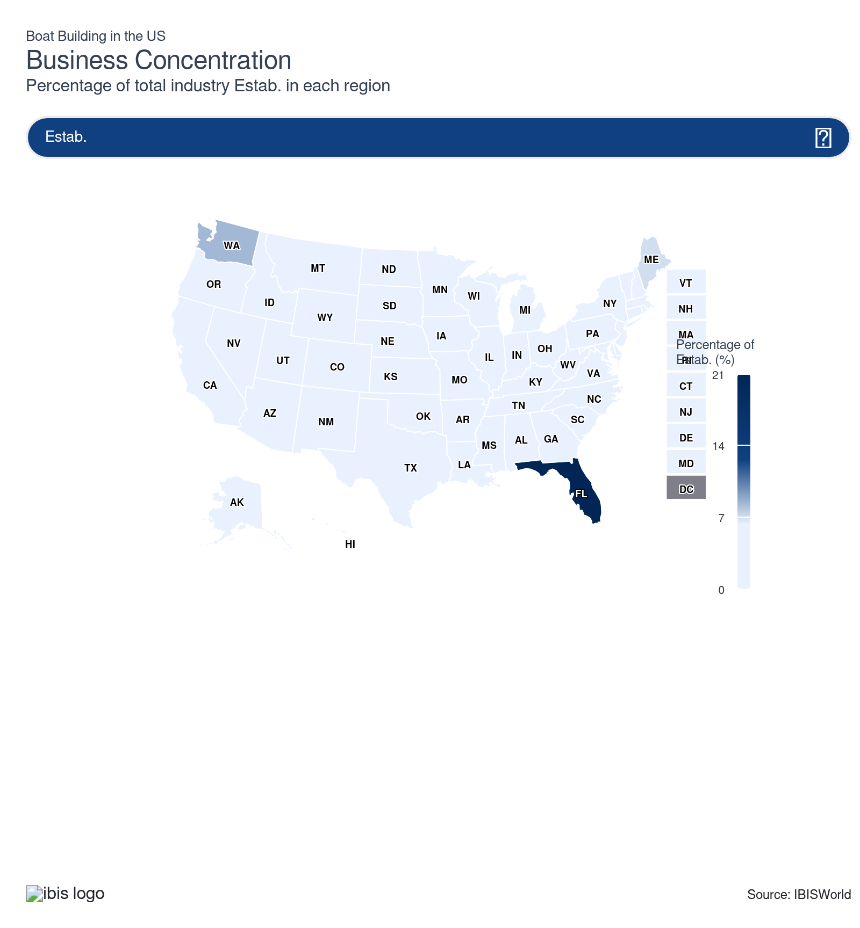
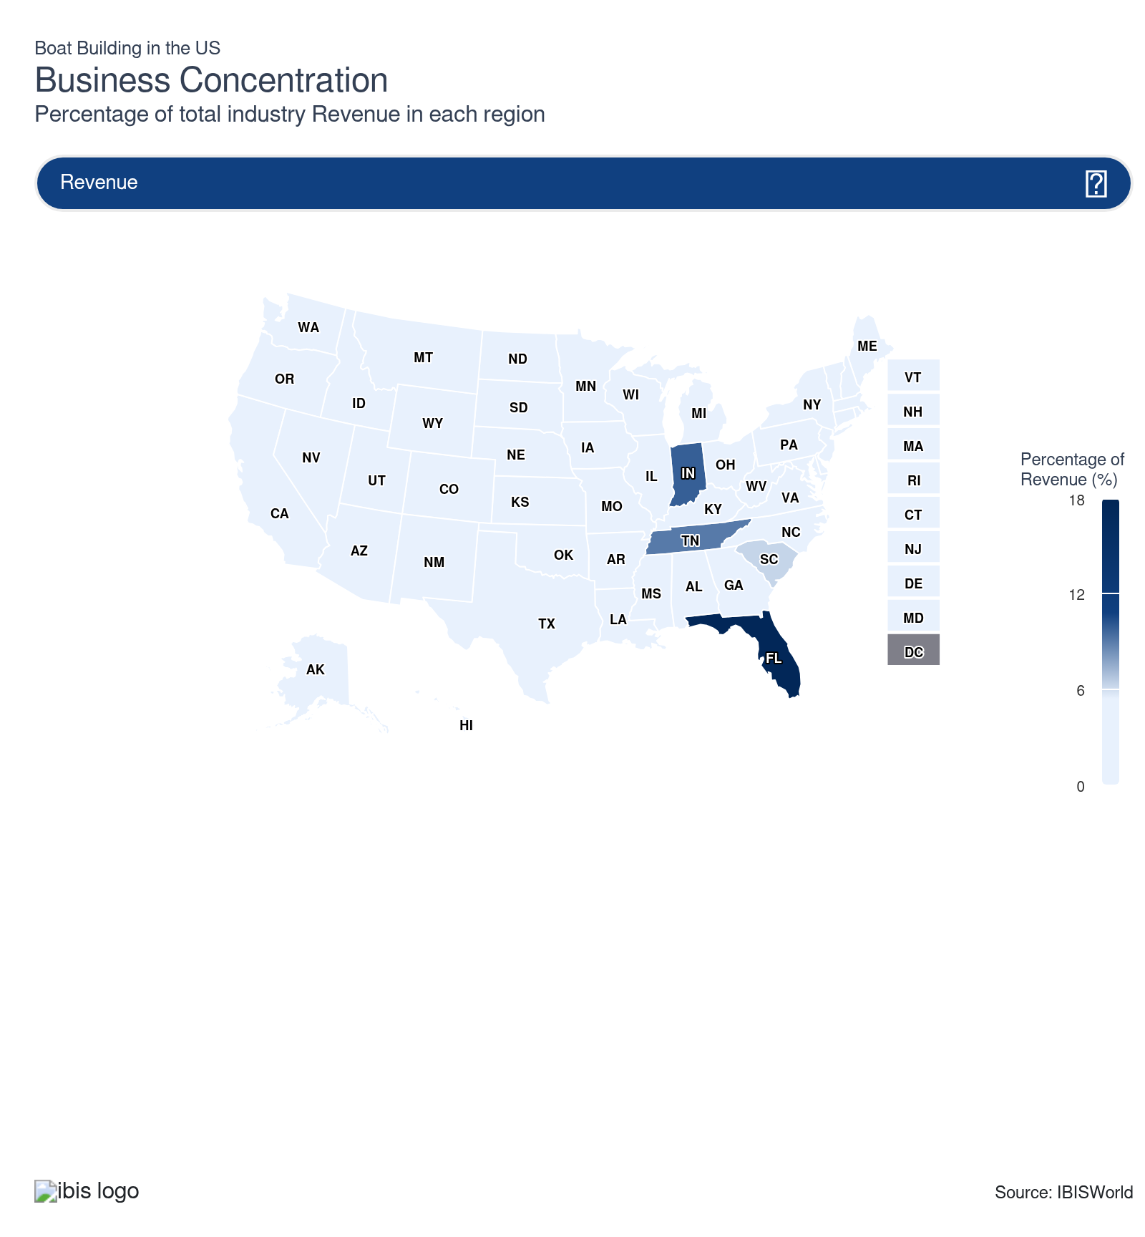
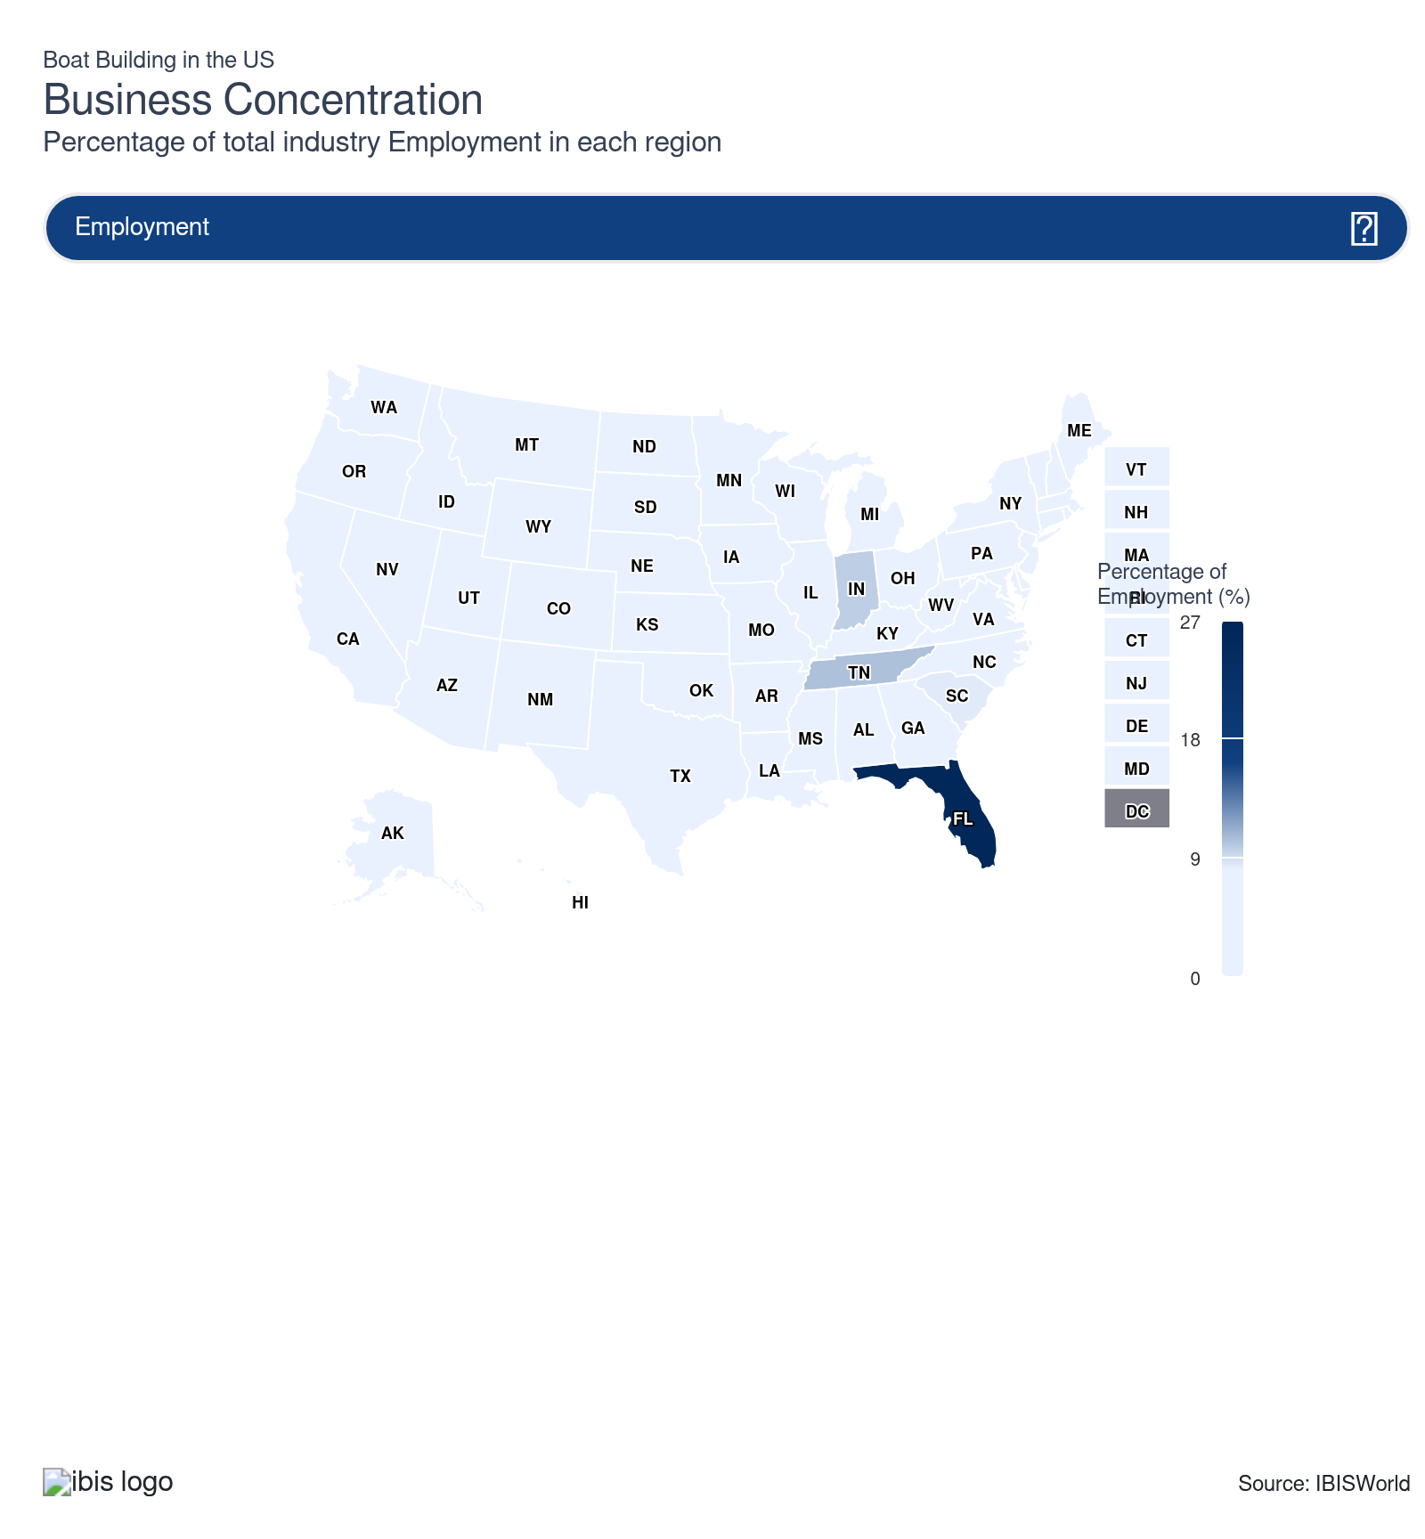
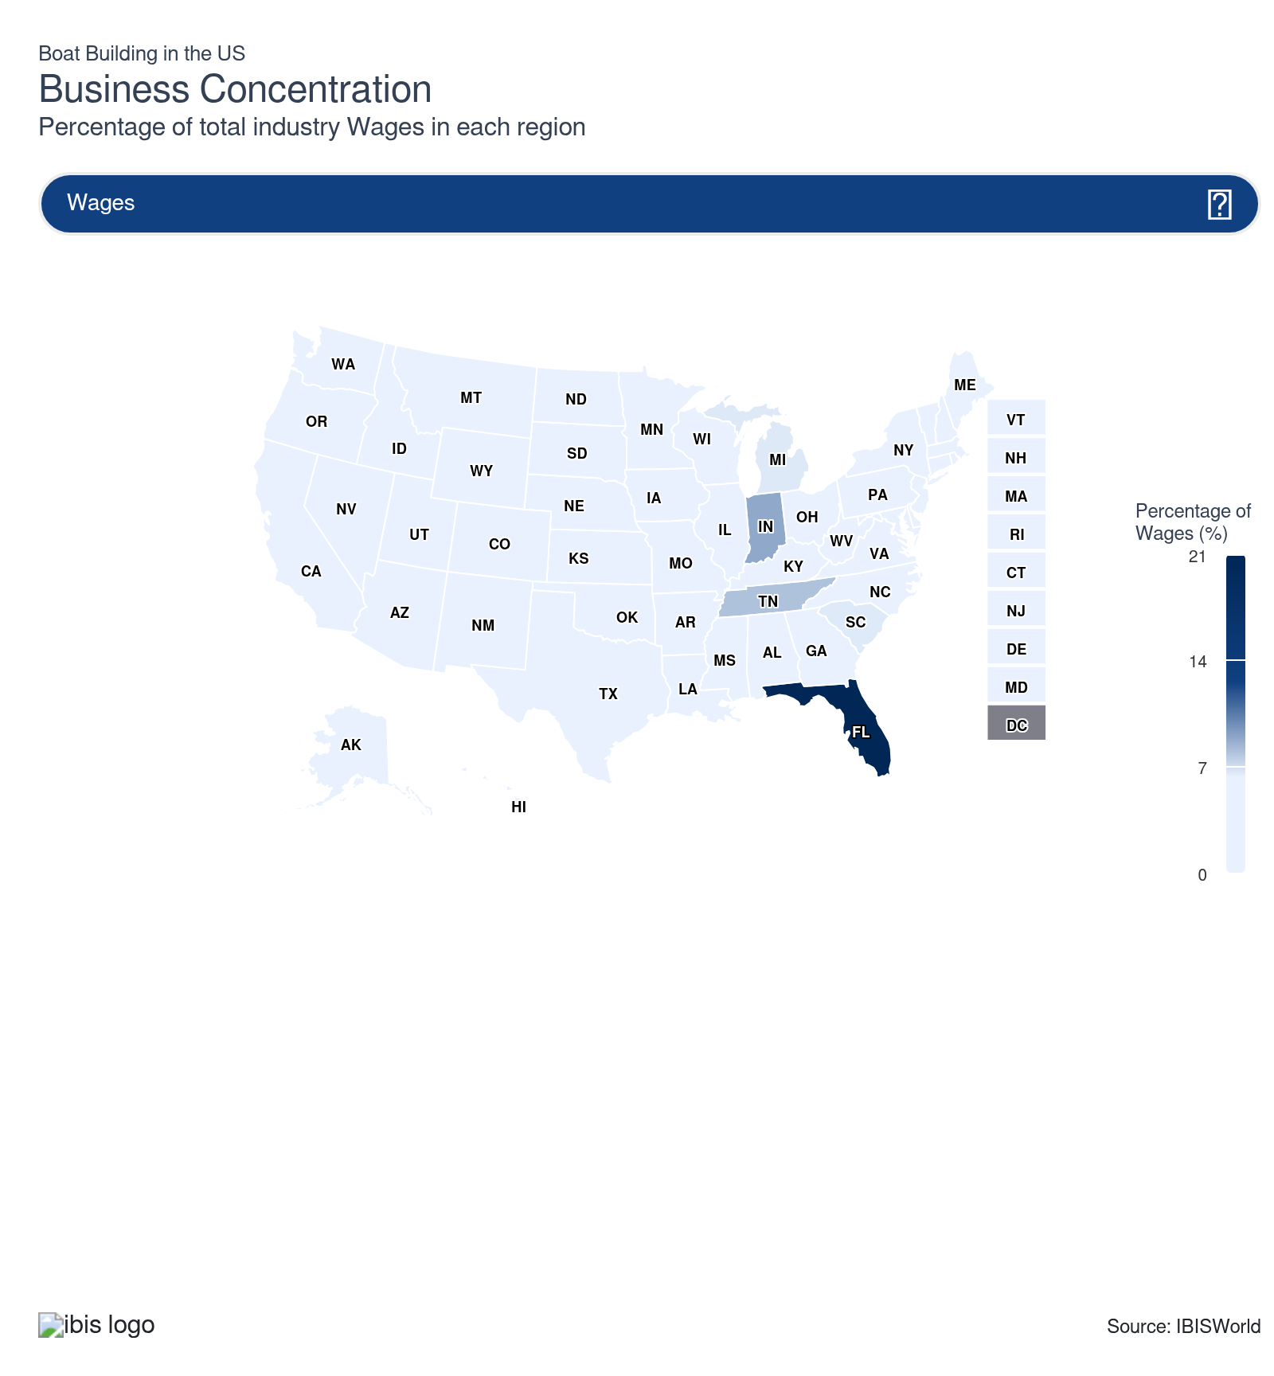
State | Estab.  Units | Estab.  % | Revenue  $m | Revenue  % | Wages  $m | Wages  % | Employment  Units | Employment  % | Population  %
Florida | 200 | 21.1 | 3,371.9 | 17.6 | 514.5 | 20.8 | 10,253 | 26.1 | 7.0
Indiana | 19 | 2.0 | 1,881.6 | 9.8 | 219.9 | 8.9 | 3,807 | 9.7 | 2.0
Washington | 79 | 8.3 | 762.7 | 4.0 | 155.1 | 6.3 | 2,423 | 6.2 | 2.3
Tennessee | 23 | 2.4 | 1,725.4 | 9.0 | 197.6 | 8.0 | 4,037 | 10.3 | 2.1
Maine | 66 | 7.0 | 443.2 | 2.3 | 67.2 | 2.7 | 1,509 | 3.8 | 0.4
South Carolina | 30 | 3.2 | 1,198.0 | 6.3 | 162.7 | 6.6 | 3,300 | 8.4 | 1.6
North Carolina | 60 | 6.3 | 877.1 | 4.6 | 125.5 | 5.1 | 2,461 | 6.3 | 3.3
Michigan | 25 | 2.6 | 1,024.8 | 5.4 | 163.6 | 6.6 | 2,973 | 7.6 | 3.0
California | 49 | 5.2 | 386.9 | 2.0 | 79.3 | 3.2 | 1,193 | 3.0 | 11.5
Texas | 31 | 3.3 | 431.4 | 2.3 | 57.1 | 2.3 | 1,001 | 2.5 | 9.4
Missouri | 19 | 2.0 | 699.6 | 3.7 | 125.2 | 5.1 | 2,890 | 7.4 | 1.8
Minnesota | 13 | 1.4 | 764.0 | 4.0 | 82.6 | 3.3 | 1,521 | 3.9 | 1.7
Louisiana | 29 | 3.1 | 427.6 | 2.2 | 78.6 | 3.2 | 1,535 | 3.9 | 1.3
Arkansas | 20 | 2.1 | 745.6 | 3.9 | 79.9 | 3.2 | 2,308 | 5.9 | 0.9
Massachusetts | 28 | 3.0 | 113.8 | 0.6 | 22.9 | 0.9 | 327 | 0.8 | 2.1
Georgia | 15 | 1.6 | 582.8 | 3.1 | 118.4 | 4.8 | 2,192 | 5.6 | 3.3
New York | 24 | 2.5 | 87.7 | 0.5 | 14.2 | 0.6 | 219 | 0.6 | 5.8
Maryland | 21 | 2.2 | 122.6 | 0.6 | 14.6 | 0.6 | 268 | 0.7 | 1.8
Oregon | 20 | 2.1 | 161.3 | 0.8 | 18.5 | 0.7 | 376 | 1.0 | 1.2
Wisconsin | 16 | 1.7 | 256.7 | 1.3 | 53.5 | 2.2 | 1,050 | 2.7 | 1.7
Rhode Island | 19 | 2.0 | 83.4 | 0.4 | 15.8 | 0.6 | 348 | 0.9 | 0.3
Oklahoma | 6 | 0.6 | 150.1 | 0.8 | 19.4 | 0.8 | 602 | 1.5 | 1.2
Mississippi | 7 | 0.7 | 155.0 | 0.8 | 20.4 | 0.8 | 584 | 1.5 | 0.9
New Jersey | 12 | 1.3 | 129.7 | 0.7 | 20.4 | 0.8 | 297 | 0.8 | 2.8
Kansas | 4 | 0.4 | 131.2 | 0.7 | 15.4 | 0.6 | 423 | 1.1 | 0.9
Alaska | 15 | 1.6 | 50.0 | 0.3 | 8.6 | 0.3 | 199 | 0.5 | 0.2
Alabama | 13 | 1.4 | 117.2 | 0.6 | 18.8 | 0.8 | 404 | 1.0 | 1.5
Illinois | 6 | 0.6 | 112.3 | 0.6 | 13.5 | 0.5 | 257 | 0.7 | 3.7
Idaho | 11 | 1.2 | 65.0 | 0.3 | 8.0 | 0.3 | 208 | 0.5 | 0.6
Virginia | 10 | 1.1 | 13.4 | 0.1 | 2.9 | 0.1 | 47 | 0.1 | 2.6
Arizona | 10 | 1.1 | 40.6 | 0.2 | 7.1 | 0.3 | 155 | 0.4 | 2.2
Iowa | 4 | 0.4 | 63.2 | 0.3 | 9.6 | 0.4 | 253 | 0.6 | 0.9
Colorado | 5 | 0.5 | 57.0 | 0.3 | 13.9 | 0.6 | 171 | 0.4 | 1.8
Ohio | 9 | 0.9 | 46.5 | 0.2 | 5.4 | 0.2 | 116 | 0.3 | 3.5
Connecticut | 6 | 0.6 | 36.0 | 0.2 | 4.4 | 0.2 | 73 | 0.2 | 1.1
North Dakota | 6 | 0.6 | 32.9 | 0.2 | 4.5 | 0.2 | 141 | 0.4 | 0.2
Utah | 6 | 0.6 | 50.3 | 0.3 | 8.1 | 0.3 | 184 | 0.5 | 1.0
Kentucky | 6 | 0.6 | 55.2 | 0.3 | 5.0 | 0.2 | 147 | 0.4 | 1.3
Montana | 5 | 0.5 | 5.7 | 0.0 | 0.6 | 0.0 | 22 | 0.1 | 0.3
West Virginia | 2 | 0.2 | 33.2 | 0.2 | 3.1 | 0.1 | 122 | 0.3 | 0.5
Pennsylvania | 4 | 0.4 | 21.8 | 0.1 | 2.7 | 0.1 | 45 | 0.1 | 3.8
New Hampshire | 4 | 0.4 | 17.2 | 0.1 | 2.4 | 0.1 | 52 | 0.1 | 0.4
Hawaii | 4 | 0.4 | 5.9 | 0.0 | 0.6 | 0.0 | 21 | 0.1 | 0.4
Delaware | 3 | 0.3 | 31.2 | 0.2 | 3.9 | 0.2 | 103 | 0.3 | 0.3
Nebraska | 2 | 0.2 | 21.2 | 0.1 | 3.2 | 0.1 | 92 | 0.2 | 0.6
Nevada | 3 | 0.3 | 22.8 | 0.1 | 3.2 | 0.1 | 85 | 0.2 | 1.0
Wyoming | 2 | 0.2 | 10.3 | 0.1 | 1.4 | 0.1 | 86 | 0.2 | 0.2
Vermont | 3 | 0.3 | 14.3 | 0.1 | 2.0 | 0.1 | 85 | 0.2 | 0.2
South Dakota | 3 | 0.3 | 9.5 | 0.1 | 1.5 | 0.1 | 59 | 0.2 | 0.3
New Mexico | 1 | 0.1 | 2.2 | 0.0 | 0.3 | 0.0 | 12 | 0.0 | 0.6

Where are industry businesses located?

Most boat builders have operations in the Southeast region
- The Southeast is home to the largest number of boat building facilities, with Florida and North Carolina accounting for the most establishments in the region. However, boatyards have many difficulties obtaining permits for new marine slips, especially in South Florida. Virginia also has some niche boat building operations, particularly related to naval vessels and autonomous craft.
- Florida, in particular, surpasses all other states in boat building. Florida's unique coastline supports commercial and personal demand for small ocean vessels, especially given the state's robust fishing and tourism industries. However, boat builders have been shifting focus to concentrate on game fishing, which requires more inputs and provides better returns.
- Being a popular retirement destination, spurs continued demand and enables Floridian manufacturers to maintain their dominance among boat builders. Even so, companies in Florida have been forced to move further north, where land is more affordable and fishing activities are becoming more prominent as more waterfront land is converted for condominiums.

Boat sales have skyrocketed out West
- The Western US boasts an extensive coastline and numerous lakes and rivers, creating ideal conditions for boating activities. This natural environment fuels demand for boats and supports a thriving boatbuilding industry. Manufacturers in this region benefit from easy access to marine environments, making it convenient to test and showcase their products.
- These states have a robust recreational boating culture, with popular activities like fishing, water sports, and leisure cruising. This cultural affinity for boating drives demand for diverse and innovative vessels, encouraging more boatbuilders to set up shop in the area. As local communities embrace water-based recreation, the market for both custom and mass-produced boats continues to grow.
- The region is also a hub for technological innovation and advanced materials, particularly around areas like Silicon Valley. Boatbuilders in this region have access to cutting-edge materials and techniques, enabling them to design and produce high-quality, innovative boats. Collaboration with tech companies and research institutions enhances their ability to integrate advanced features, attract eco-conscious consumers and remain competitive in a dynamic market.

Maine leads the industry in New England and remaining regions
- The region is surrounded by the Atlantic Ocean and dotted with numerous bays, inlets, and rivers, providing diverse environments for boating. These waterways support a variety of marine activities, from commercial fishing to recreational sailing, driving demand for different types of boats. The proximity to water also facilitates easy testing and demonstration of boats, making it an ideal location for manufacturers.
- In particular, Maine and Massachusetts house a disproportionate percentage of boat builders compared with the state's population. The region has robust lobstering and fishing industries, contributing to massive demand for new boats. Brands like Boston Whaler hold a massive share of revenue and establishments in the region.
- The Great Lakes and Mid-Atlantic regions are home to some establishments due to their vicinity to large bodies of water. By comparison, the Southwest, Plains and Rocky Mountains don't produce boating goods since shipping to larger bodies of water is costly and too detrimental to revenue.
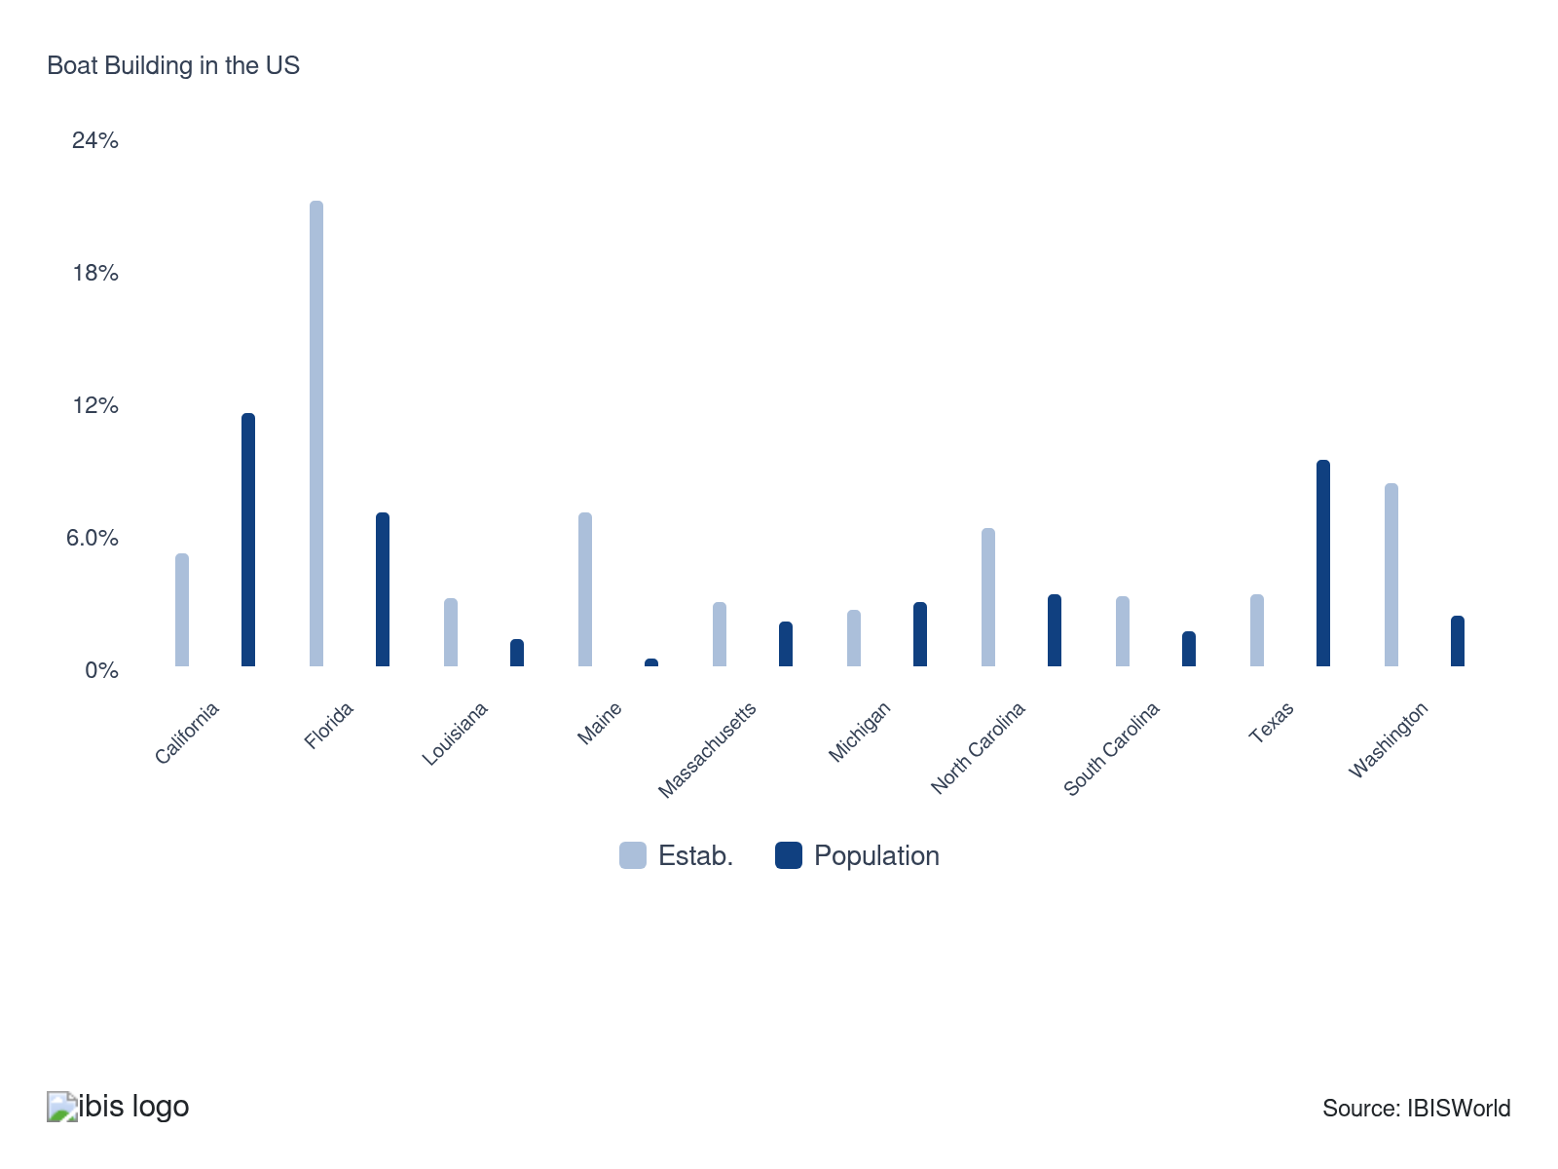

How do businesses use location to their advantage?
Operate in a location that is close to key markets
Most boat builders are located near key downstream markets in the West, Southeast and Mid-Atlantic regions. This minimizes transportation costs and helps builders establish connections with buyers.
Secure export markets
Larger boat builders in this industry have developed market penetration strategies. These strategies have been intended to grow and develop products and market opportunities overseas.

6. Competitive Forces
https://my.ibisworld.com/us/en/industry/33661b/competitive-forces

Key Takeaways
- Boat builders have faced intensifying competition from small, innovative startups. Consolidation among boat builders will expand as larger producers attempt to improve their market share and expand into new, more lucrative markets.
- Economies of scale are vital for success. Research and development into streamlined production will be crucial for boat builders seeking to stand out.

Concentration
Low
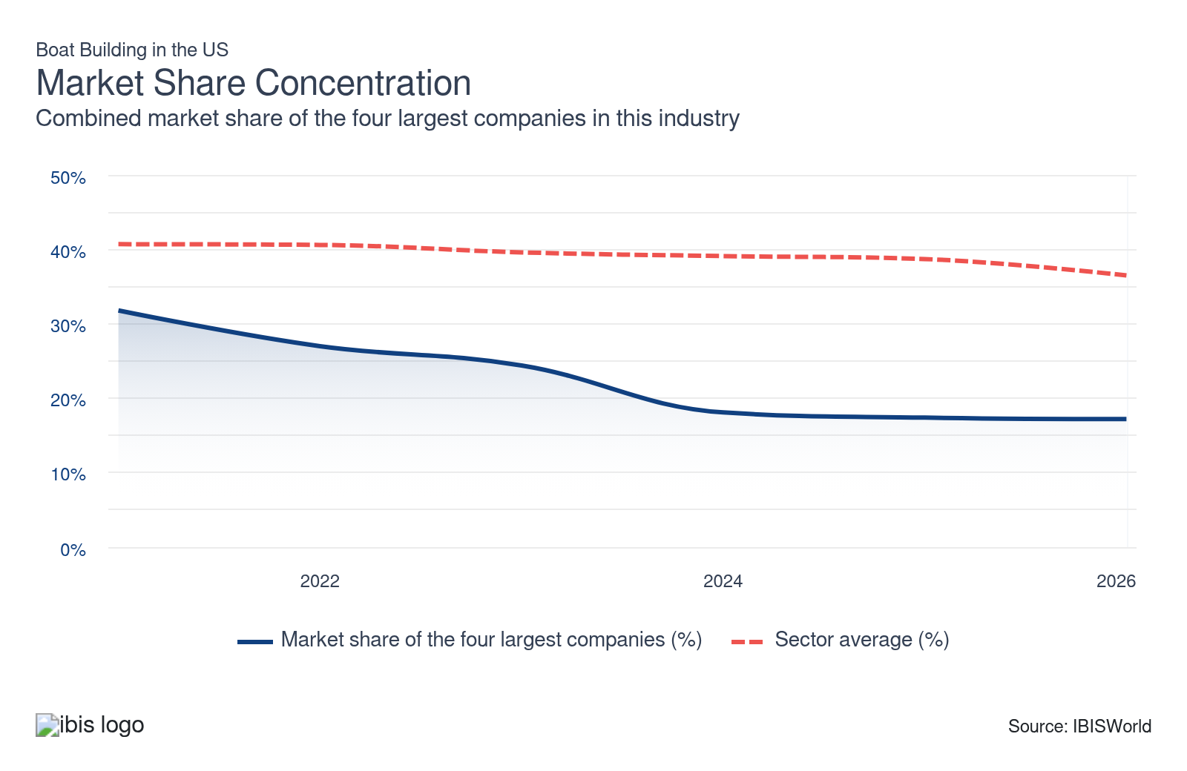

What impacts the industry’s market share concentration?

Small manufacturers dominate key niches within the broader boat building market
- Most domestic boat builders are primarily small, independently owned manufacturers. These companies lack the economies of scale necessary to expand across the country and internationally. They only operate one or a few facilities, resulting in low market share concentration and limited operational scopes.
- This trend has encouraged companies to specialize in various niche segments, ranging from extreme sports-oriented canoe and unpowered boat production to luxury yacht or sailboat customization. Boat builders often lack significant economies of scale and struggle to capture demand across multiple segments.

Leading companies have consolidated over the past few years
- Many companies have started to consolidate, targeting innovative boat builders with sustained success in various niches or ancillary services that boost technology and systems internally. For example, Brunswick acquired Garelick Manufacturing, a Minnesota-based manufacturer of marine products. This strategy has enabled Brunswick to consistently increase its market share.
- Business locations are also concentrated in coastal areas, enabling larger manufacturers to dominate these areas and acquire smaller competitors, leading to increased consolidation. Companies that operate in regions without large bodies of water often fail.

Continued revenue growth will drive entry, despite consolidation attempts among leaders
- Market share concentration is expected to remain steady through the end of the current period. Continued revenue growth will create entry opportunities, leading to an uptick in entry from smaller start-ups and offsetting M&A from industry leaders.
- Boat builders produce a variety of products for varied and niche markets. This factor enables these smaller-scale entrants and longstanding bespoke competitors to specialize and effectively capture market share even as consumer preferences shift toward value-priced, fuel-efficient boats with cutting-edge technology.
- Large boat builders have the economies of scale and research and development infrastructure needed to meet these demands. Changing consumer tastes will help larger companies capture a larger share of the market, but price competition from imported substitutes will continue to promote market fragmentation.

How do successful businesses handle concentration?
Appeal to business from a desired demographic
Boat builders that target high-end clientele are increasingly using rare and innovative inputs to differentiate from competitors and charge a price premium.
Establish overseas networks for developing export markets and sourcing imports
Larger boat builders in this industry have developed market penetration strategies. These strategies have been intended to grow and develop products and market opportunities overseas.

Barriers to Entry
Moderate | Increasing

What challenges do potential industry entrants face?

Legal
- Commercial boat builders must register with the US Coast Guard and obtain a manufacturer's ID code from their state boating law administrator. Personal boat builders, however, are exempt from most regulations except for a hull ID number and safety standards. Companies must also adhere to increasingly strict emission, safety and labor regulations.

Start-up Costs
- Boat builders face high start-up costs for materials, labor, equipment, molds and facilities. However, many companies are small, independent producers that make custom-built products. Extensive capital requirements prevent companies from challenging Brunswick. Securing the necessary business licenses and permits can also be a major cost.

Differentiation
- Entrants must contend with established boat builders with dedicated, loyal consumer bases. Certain brands display high brand loyalty in specific markets, like fishing or yachting, making it difficult to compete. Most existing builders have an established foothold on either coast or in the Great Lakes region, making it difficult to break into these more saturated regions.

Labor Expenses
- Skilled labor is a crucial investment for boat builders, especially those in higher-end markets that rely on customization. In comparison, boat builders entering the mass production segment rely more heavily on capital expenditure and economies of scale. These producers must overcome high initial capital costs when purchasing the required machinery, equipment and technology.

Capital Expenses
- Companies must balance investment in the latest capital and skilled labor to find success. Companies in high-end markets rely more heavily on skilled labor, relying primarily on customization and innovation. More generic builders and parts manufacturers notably prioritize automation machinery to keep costs down and gain a competitive edge.

How can potential entrants overcome barriers to entry?
Develop a skilled labor force
Boat builders must develop skilled labor forces to compete with imports and other domestic boat builders. Custom builders heavily rely on labor.
Secure economies of scale
Operating within this industry requires a moderate level of capital investment. The ability to spread the fixed costs across more production units and achieve scale economies is important to competition within this industry.

Substitutes
Low | Steady

What are substitutes for industry services?

Imports
- Imports pose a moderate threat to domestic boat builders, despite accounting for less than 15.0% of domestic demand. Imports threaten both ends of the market, with foreign importers holding key brands across both luxury and generic options.
- Domestic buyers commonly purchase imports from Italy and France. These manufacturers often create high-end luxury boats to compete with similar domestic brands. Certain Italian companies, like Fincantieri, operate extensively internationally and pose a direct threat to Brunswick.

Ship Building
- Shipbuilders create larger barges, transports and military vessels for commercial and defense clients. While some superyachts fall under ship designations, shipbuilders don't target consumer markets and play a significantly different role than boat builders, providing larger commercial and defense vessels.
- Given the lack of overlap, boat builders can carve out dedicated niches in private and government markets, primarily with the Coast Guard. Overall, boat builders face little competition from external manufacturers. Instead, boat builders primarily compete with foreign builders.

How do successful businesses compete with substitutes?
Appeal to business from a desired demographic
Many boat builders appeal to luxury markets to attract wealthy customers and compete with high-end foreign brands.
Secure economies of scale
Operating within this industry requires a moderate level of capital investment. The ability to spread the fixed costs across a greater number of production units and achieve scale economies is important to competition within this industry.

Buyer & Supplier Power
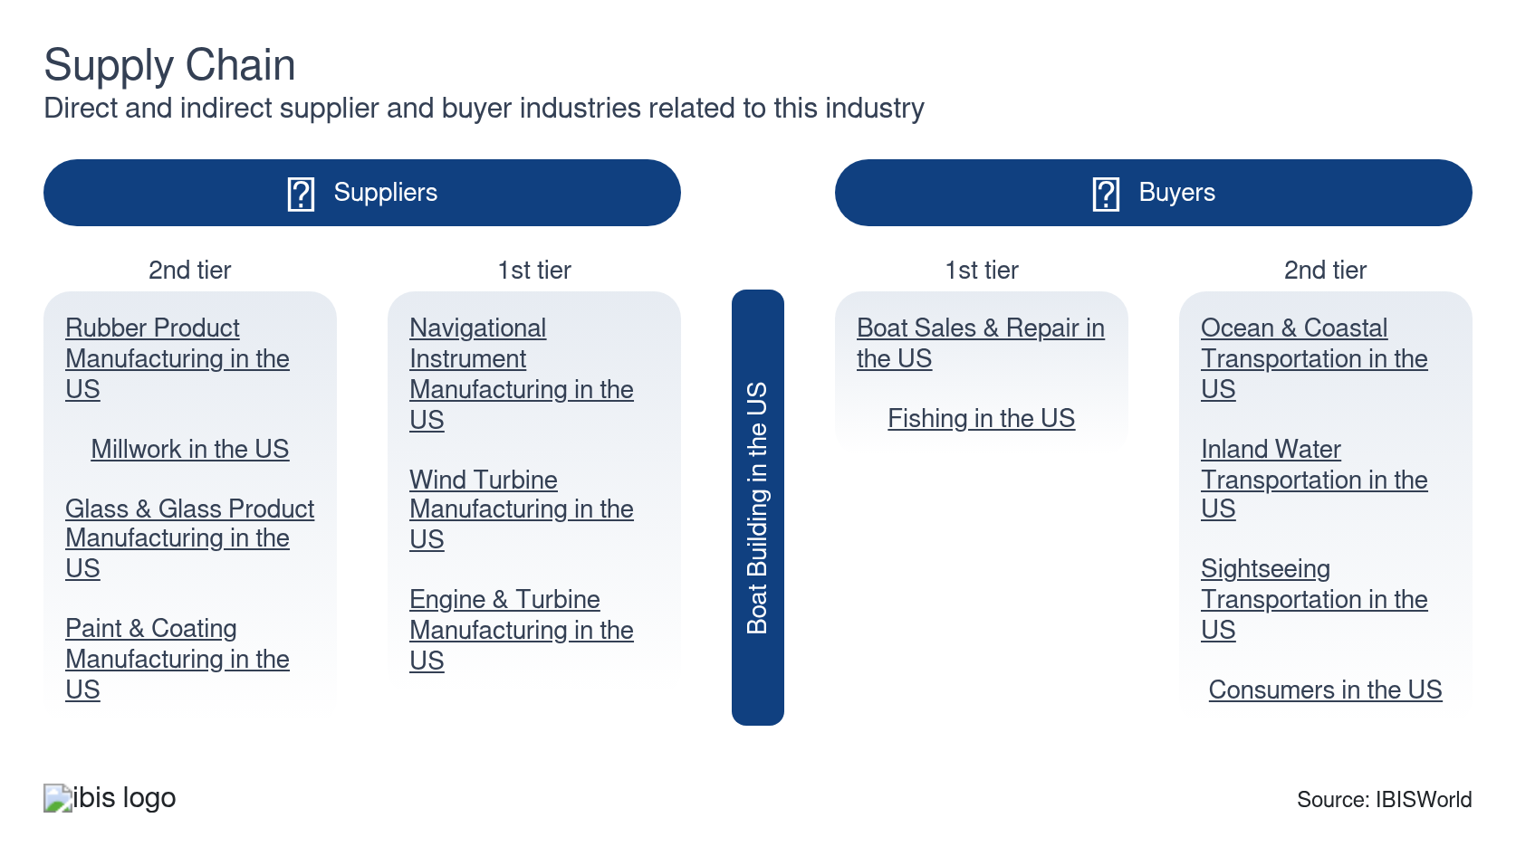

What power do buyers and suppliers have over the industry?

Buyers: buyers drive demand trends
Moderate | Steady
- Downstream buyers drive demand for boat building. Customers fall into three main categories: individual households, commercial buyers and governmental clients. These markets display varying degrees of purchasing power, with government contracts posing unique threats and opportunities for boat builders.
- Household demand is characterized by single-product purchases, with an increasing emphasis on customization among upper quintile incomes. Boat builders have significantly more pricing power in these higher-end markets compared with non-motorized boat production and standard motorboats. Commercial and government clients more frequently demand bulk production of standardized products. Boat builders often specialize in one of these markets.
- In general, generic segments face extensive competition from low-cost foreign producers. Even so, foreign brands, such as Fincantieri, hold significant power in luxury markets, too, significantly reducing domestic pricing power. Companies must ensure products meet niche buyer standards across fishing, yachting or sport markets to ensure stable demand.

Suppliers: major suppliers dictate price hikes
High | Steady
- Companies require a wide range of inputs, including metals, plastics, lumber and electronic components. Many companies maintain globalized and diversified supply chains to gain access to less expensive inputs and prevent localized supply chain disruptions. This strategy helps limit supplier power.
- Material prices, notably plastics and resins, have increased significantly. Leading boat builders often pass these costs further down the supply chain to consumers to mitigate supply chain disruptions, but small companies may struggle without bulk purchasing agreements. Even so, motorboats, yachts, sailboats and other more expensive or advanced boats require higher-priced electronics inputs, often resulting in higher supplier power. The PPI for both electronic components and plastic materials also suggests relative price inelasticity.

How do successful businesses manage buyer & supplier power?
Secure export markets
Larger boat builders have developed market penetration strategies. These strategies have been intended to grow and develop products and market opportunities overseas.
Operate in a location that is close to key markets
Most boat builders are located near key downstream markets in the West, Southeast and Mid-Atlantic regions. This minimizes transportation costs and helps companies build relationships with buyers.

7. Companies
https://my.ibisworld.com/us/en/industry/33661b/companies

Key Takeaways
- Brunswick remains the industry's largest producer by a wide margin. Brunswick has increased its market share concentration through strategic acquisitions and research and development.
- Smaller companies make up the majority of the boat-building industry. Companies often prioritize specific niches, leading to notable market fragmentation and varied market saturations.

Market Share
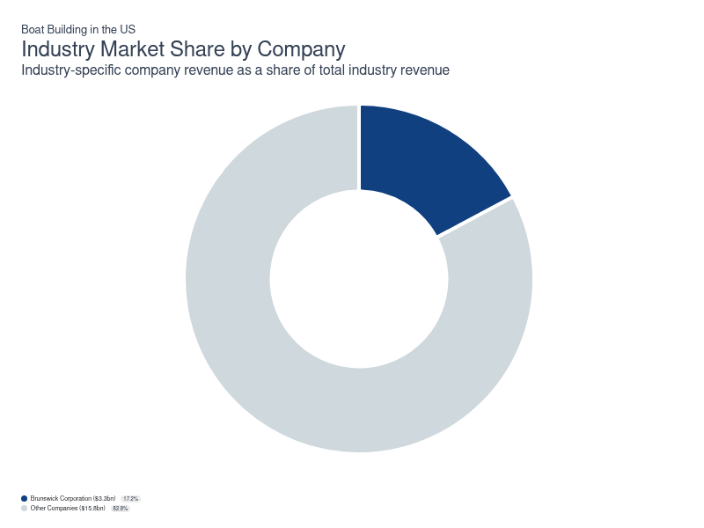
Chart displays current year only in the PDF version of this report. You can view and download chart for all other years associated with this industry on my.ibisworld.com.

Companies
Company | Market Share (%)  2026 | Revenue ($m)  2026 | Profit ($m)  2026 | Profit Margin (%)  2026
Brunswick Corporation | 17.1 | 3,276.6 | 234.2 | 7.1

Brunswick Corporation
Brunswick Corporation
Company Details
Company Details
Industry Specific Revenue (2026) | $3.3bn
Industry Profit (2026) | $234.2m
Company Employees (2026) | 19,000
Market Share (2026) | 17.1%

Description
Description
Brunswick is a public company headquartered in Illinois with an estimated 19,000 employees. In the US, the company has a notable market share in at least one industry: Boat Building, where they account for an estimated 17.1% of total industry revenue.

Brands and Trading Names
Brands and Trading Names
- Bayliner
- BLA
- Boston Whaler
- Crestliner
- Cypress Cay
- Harris
- Heyday
- Kellogg Marine Supply
- Land N' Sea
- Lankhorst Taselaar
- Lowe
- Lund
- Mercury
- Mercury Marine
- Mercury Precision Parts
- Princecraft
- Quicksilve
- Sea Ray
- Seachoice brands
- Thunder Jet

Company’s Industry Revenue, Market Share, and Profit Margin Over Time
Company’s Industry Revenue, Market Share, and Profit Margin Over Time
Year | Industry Revenue ($ million) | Market Share (%) | Profit Margin (%)
2020 | 3129 | 29.7 | 11.4
2021 | 4208 | 31.8 | 14.1
2022 | 4545 | 27.0 | 16.2
2023 | 4395 | 24.4 | 14.8
2024 | 3362 | 18.1 | 9.1
2025 | 3277 | 17.4 | 7.1
2026 | 3277 | 17.1 | 7.1

What's impacting Brunswick Corporation's performance?

Brunswick announces launch of Veer brand
- Brunswick has developed a new electric-propulsion boat brand, Veer, to appeal to a new generation of potential customers and support the company's stated commitment to sustainable boating. The first model is titled the X13. The new initiative and vertical will enable Brunswick to tap into growing electrification markets, potentially receiving government support from various electrification rebates.

Brunswick showcases premium boat innovations
- Brunswick is leaning into premium product and technology leadership in the US market, reporting strong 2025 Fort Lauderdale International Boat Show results with higher unit sales and revenue across boat brands and record Mercury Marine outboard share. The company has used major US venues and CES showcases to highlight autonomous features like the SIMRAD AutoCaptain system and Boston Whaler autodocking concepts, alongside high-power electric and V12 outboards, reinforcing a narrative of innovation-driven growth in propulsion, electronics and on-water “boating intelligence.”

The company offers affordable pricing to remain competitive
- The company experiences significant competition from other, small boat builders; however, the company's size, scope and retention of key brands, like Boston Whaler, gives the company a strong position. The company especially competes with other manufacturing companies to retain independent boat dealers and distributors. These dealers and distributors are needed for the company and its competitors to sell their products. Therefore, the company’s success is highly dependent on its ability to develop a network of dealers. Furthermore, the company suffers competition from other companies that offer alternative products that are priced more affordably. In turn, the Brunswick Corporation aims to maintain an aggressive pricing strategy.

You can view and download company details on my.ibisworld.com.

8. External Environment
https://my.ibisworld.com/us/en/industry/33661b/external-environment

Key Takeaways
- Regulation focuses on safety and environmental sustainability. Regulatory policies ensure product safety and environmental friendliness. Small, personal watercraft such as canoes are exempt from most regulations, save for mandatory hull ID numbers.
- Companies receive mild government support. The government acts as a minor buyer for boats and helps facilitate favorable trade conditions. Boat builders may also qualify for small business loans or innovation-focused grants.

External Drivers

What demographic and macroeconomic factors impact the industry?
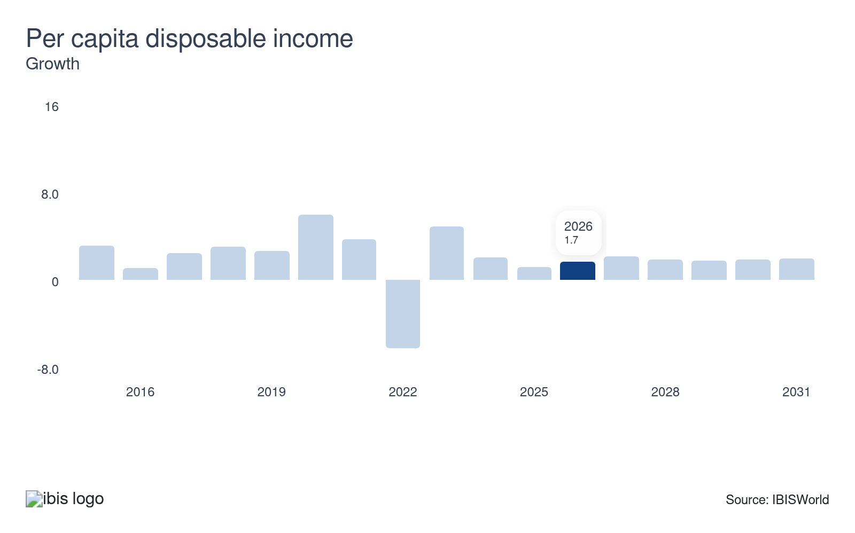
Demand for boat building closely relates to overall economic growth. In particular, higher discretionary income levels encourage boat purchases from consumer and commercial markets. Similarly, higher incomes spur demand for higher-end boats with powerful motors and more value-added amenities. Rebounding per capita disposable income can present new opportunities for domestic boat builders.
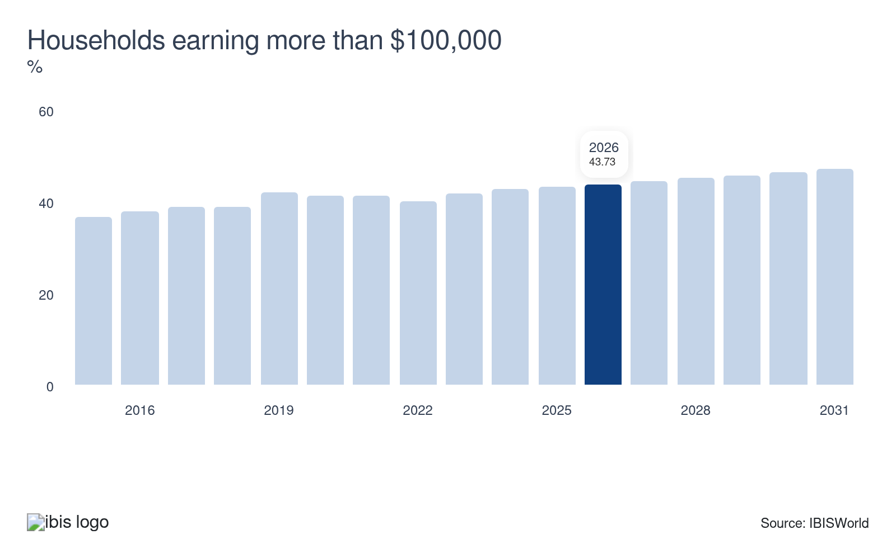
Boats are expensive purchases; lower-income buyers commonly struggle to afford higher-end boats, payment loans and associated upkeep and fuel costs, instead purchasing more generic and sometimes unmotorized products, like canoes. Therefore, the industry's primary market is households earning more than $100,000. In general, the economy's highest earners make up a significant portion of high-end boat purchases.
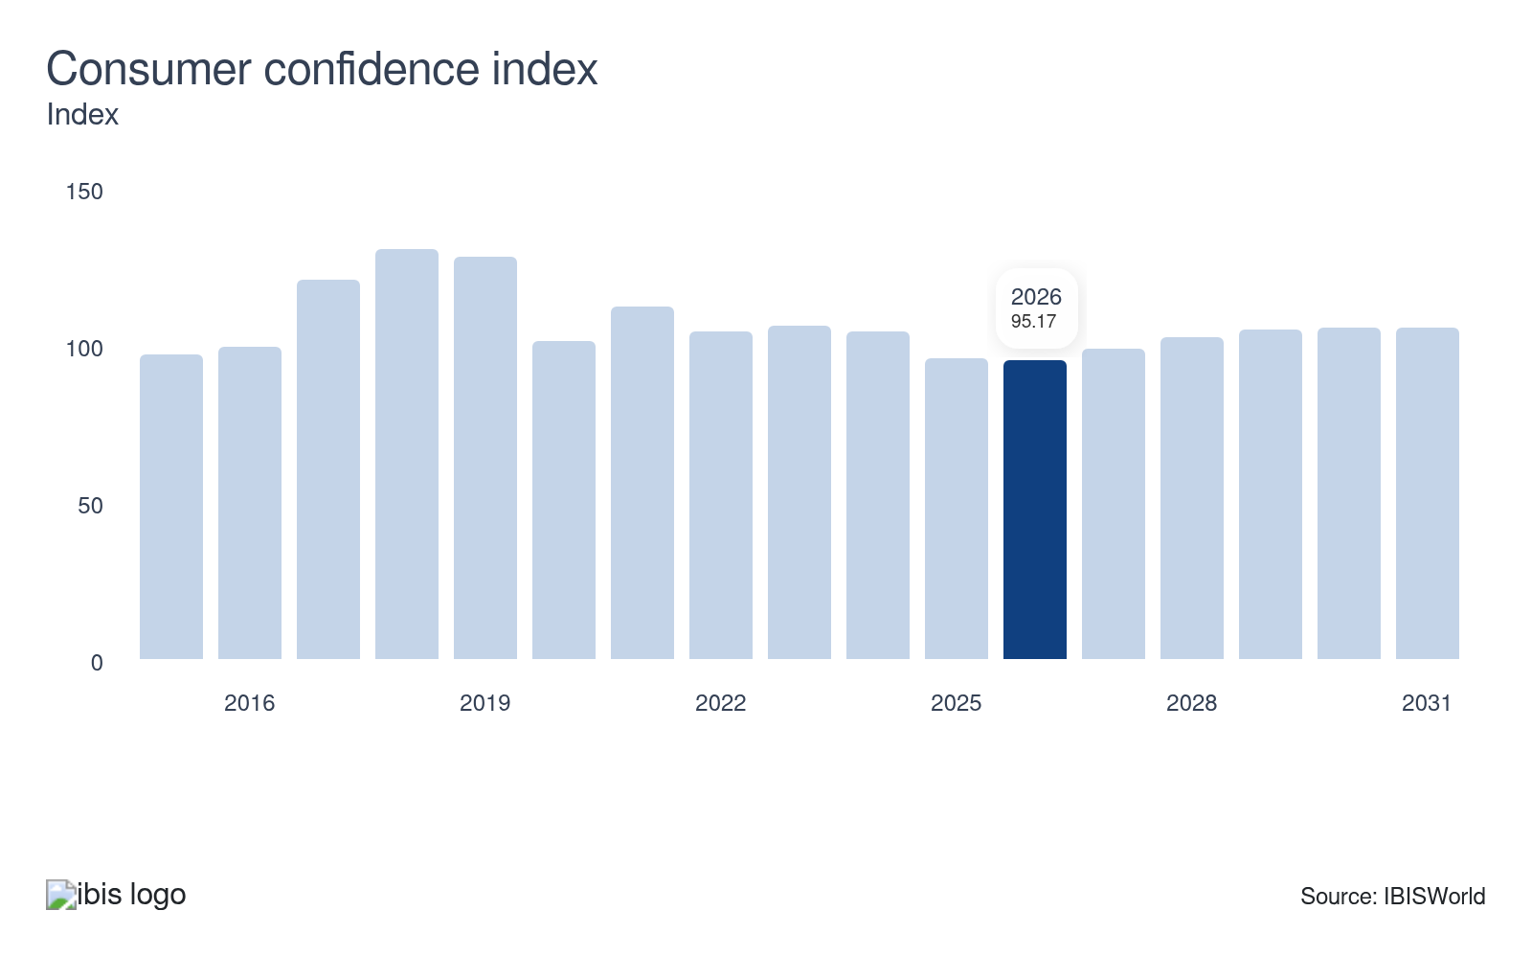
As a measure of people’s attitudes toward spending, the Consumer Confidence Index indicates spending habits on superfluous and luxury goods, including boats. Higher consumer confidence suggests greater consumer willingness to purchase luxury goods. Volatility in the consumer confidence index amid high interest rates has posed a threat to domestic boat builders.
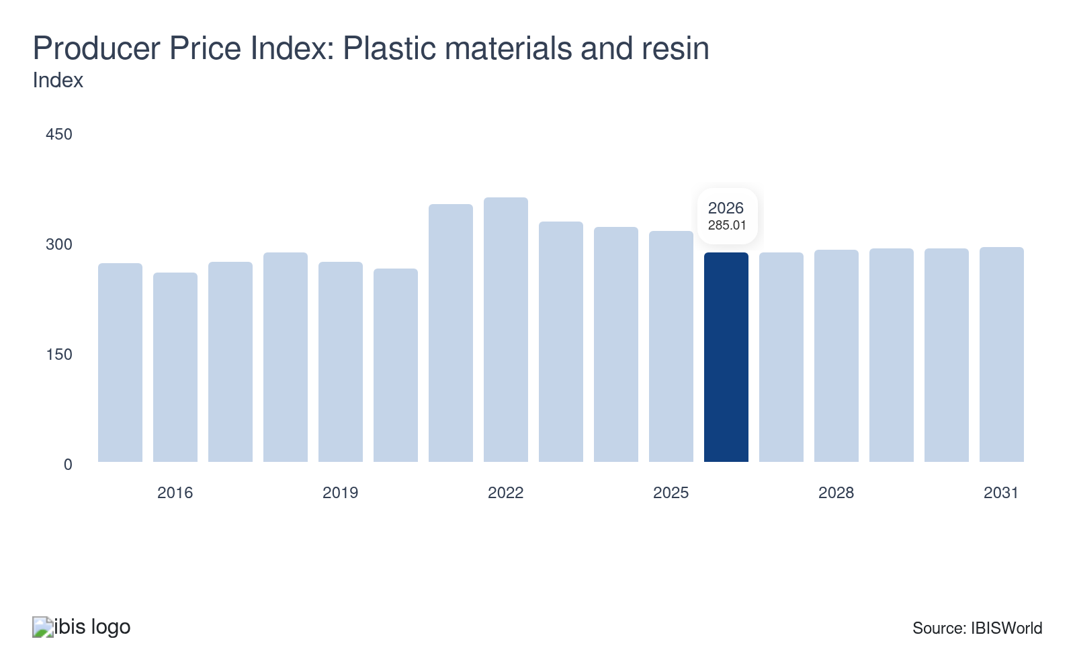
Boat builders rely on raw and semifinished inputs, including plastic materials and resin. While any change in input costs could cause significant profit fluctuations, an increasing price of plastics also enables manufacturers to charge higher prices for their goods, which increases boat builders’ revenue. Larger boat builders can more easily leverage brand reputations to pass costs onto buyers, while smaller builders often see profit declines as plastic prices rise.
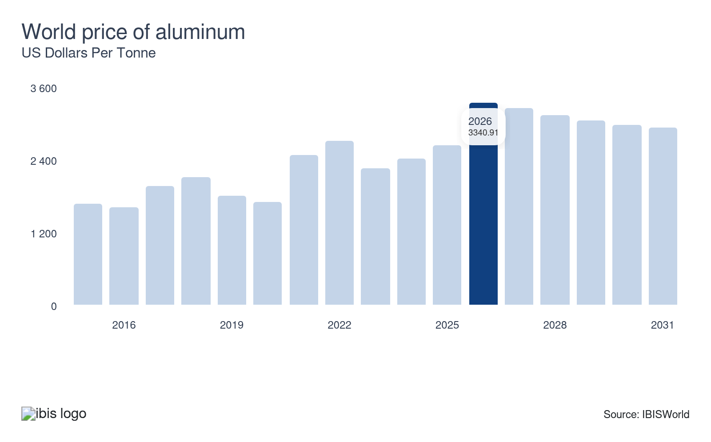
When aluminum prices rise, boat builders may pass on increased costs to customers in the form of higher boat prices to raise revenue. However, if demand conditions are not strong enough, producers may have to absorb some of the cost, decreasing profit. In general, larger producers have greater price-setting power, enabling them to pass off aluminum price spikes and constraining profit for the industry.

Regulation & Policy
Moderate | Steady

What regulations impact the industry?

US Coast Guard and federal legislation
The US Coast Guard (USCG) plays a critical role in regulating the safety, construction and operation of boats. Their regulations cover a wide range of areas, including hull design, stability, flotation, electrical systems and fire protection. Boat builders must ensure compliance with USCG standards to receive certification before vessels can be sold or operated legally. These regulations aim to protect passengers, operators and the environment by ensuring vessels meet stringent safety requirements. Keeping up with evolving USCG rules is essential for builders to maintain market access and avoid costly recalls or penalties.

Workplace safety regulations
The Occupational Safety and Health Administration (OSHA) regulates workplace safety for boat builders. This ensures that manufacturing facilities maintain safe working conditions, protecting employees from hazards. Compliance involves proper training, equipment, and protocols to prevent accidents and injuries. A safe workplace boosts morale and productivity, and it aligns with federal mandates to safeguard workers’ well-being. Many boat builders and part manufacturers are also unionized; companies must negotiate union standards and requests, especially regarding pay and safety.

Environental regulations
Boat builders must adhere to EPA regulations that address emissions and pollution control. The EPA sets limits on engine emissions for marine vessels, including pollutants like nitrogen oxides and hydrocarbons, to reduce environmental impact. Builders of recreational boats with combustion engines must comply with these emission standards, often collaborating closely with engine manufacturers to meet the requirements. Additionally, regulations govern the handling and discharge of waste, such as chemicals and fuels. Adhering to EPA rules helps boat builders minimize environmental harm and align with growing sustainability expectations.

American Boat and Yacht Council (ABYC) standards
While not a federal regulation, ABYC standards are widely recognized guidelines that influence boat construction and safety. The ABYC develops voluntary consensus standards covering electrical systems, fuel systems, ventilation, and more. Many insurance companies and USCG certifications reference ABYC standards, making adherence a practical necessity for builders focused on quality and market acceptance. Following these standards helps boat builders enhance safety, reliability, and customer satisfaction.

Federal Trade Commission (FTC) boating industry guides
The Federal Trade Commission oversees advertising and marketing practices through the Boating Industry Guides. These rules ensure that boat builders and dealers provide truthful, clear, and non-misleading information to consumers, including details about warranties, prices, and safety features. Compliance guarantees transparency and fosters consumer trust. Builders must be mindful of these guidelines in all promotional materials, helping them avoid legal issues or reputational damage.

National Marine Manufacturers Association (NMMA) certification
The NMMA offers certification programs that verify boats meet applicable safety and construction standards, including USCG requirements. Although voluntary, NMMA certification is highly valued in the industry and often demanded by dealers or buyers. Builders that pursue NMMA certification demonstrate their commitment to quality and gain a competitive edge in the marketplace. It also assists in streamlining compliance with federal regulations while boosting consumer confidence.

Assistance
Moderate | Steady

What assistance is available to this industry?

Small Businesss Administration (SBA) loans
The SBA offers various loan programs tailored to small businesses, including boat builders. These loans can be used for purchasing equipment, expanding facilities, or managing operational costs. With lower interest rates and favorable terms, SBA loans provide crucial financial backing that can help boat builders grow their businesses and weather economic fluctuations. By accessing this capital, builders can invest in innovation and maintain a competitive edge in the market.

Manufacturing Extension Partnership (MEP)
The MEP is a network under the National Institute of Standards and Technology (NIST) that provides valuable consulting and resources to manufacturers, including boat builders. MEP centers offer guidance on process optimization, product development, and workforce training. Through personalized support, boat builders can enhance efficiency, reduce costs, and adopt cutting-edge technologies. This assistance helps builders improve quality and performance, driving growth and sustainability in the industry.

US Maritime Administration (MARAD) grants and support
MARAD, part of the Department of Transportation, offers grants and technical assistance aimed at enhancing the US maritime industry, which includes recreational and commercial boat builders. Programs like the Small Shipyard Grant provide funding to modernize facilities, purchase innovative tools and improve workforce skills. This support helps the industry boost productivity, incorporate new technologies and strengthen the domestic boat building sector.

Trade Associations
The American Boatbuilders Association (ABA) and the National Marine Manufacturers Association (NMMA) are two of the largest associations that aid boat builders, providing resources and advocacy for boat builders. These groups offer market research, networking opportunities and lobbying efforts to influence policy positively. By participating in these associations, builders gain access to valuable insights and a collective voice in shaping industry regulations. This support fosters a collaborative environment that helps businesses thrive and adapt to changing conditions.

9. Financial Benchmarks
https://my.ibisworld.com/us/en/industry/33661b/financial-benchmarks
Profit Margin  0.9 %  ↓ Lower than sector | Average Wage  $63,110  ↓ Lower than sector | Largest Cost  Purchases  56.2% of Revenue

Key Takeaways
- Purchases remain the largest expense. Companies have endured volatile supply chains, contributing to longer lead times and volatile profit trends. Many companies have developed strategic backlogs and other supply chain redundancies to prevent future disruptions.
- Boat builders rely on skilled labor to design custom products. Custom-built, fuel-efficient, technologically advanced products draw significant demand and generate higher returns.
- The conflict in Iran poses a major threat to the industry's purchasing costs and profitability. Higher crude oil prices have a major impact on supply chains, including input availability and shipping costs, while also contributing to higher operating costs, ultimately lowering demand and constraining returns.

Cost Structure
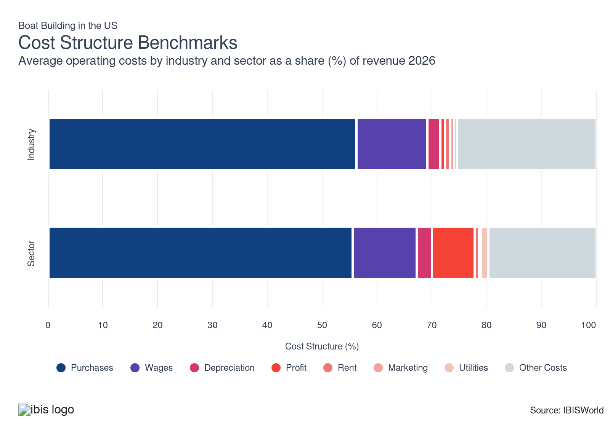
Chart displays current year only in the PDF version of this report. You can view and download chart for all other years associated with this industry on my.ibisworld.com.

What trends impact industry costs?

Boat builders rely on a wide range of complex inputs
- Boat builders primarily rely on raw and semifinished inputs, including fiberglass, plywood, paints, steel, aluminum, epoxies and cores. Smaller boat manufacturers without in-house research and development teams may also need to purchase designs, parts and components from third-party providers. This creates a dichotomy between the industry; larger builders often have in-house R&D and design, therefore allocating more expenses to wages and R&D, while smaller companies rely more on purchases, including inputs and designs.
- Boat builders have faced significant supply chain volatility following the pandemic, the Russian invasion of Ukraine and major conflicts in the Middle East. Metal, lumber, plastic and electronic component prices spiked, pressuring profit. Even so, many leading companies were able to pass costs onto buyers, leveraging strong reputations. Also, companies commonly maintain globalized supply chains to reduce input costs and supply chain volatility. Companies with less supply chain flexibility struggled with profitability.
- Purchases are also relatively inelastic, with the PPI for plastic materials and resin continuing to climb through the current period. Most small manufacturers lack the scale and scope to negotiate with materials providers, leaving them exposed to price changes. Brunswick is a major exception, displaying a dominant market share and holding significant pricing power over suppliers and greater supply chain diversity.
- Companies, especially smaller manufacturers that rely on seasonal demand trends and government contracts, also purchase contracted labor. This strategy helps companies cut costs during weak periods and rapidly scale up after winning contracts or in the summer months.

R&D costs vary by scope, with motor boat producers rapidly advancing propulsion technology
- Leading boat manufacturers have extensive research and development outlays, often straddling commercial and defense markets. These companies have invested in electric propulsion, flotation and various safety measures to help differentiate from competitors in a competitive international landscape.
- Smaller boat builders lack the resources to invest in new technology and design; instead, these companies purchase designs from larger manufacturers or act as contract manufacturers. Companies also maintain a wide array of other costs, including legal and warehousing-related expenses.

Boat manufacturers rely on skiled labor
- Wages represent the industry's third-largest expense; boat building is highly labor-intensive, requiring skilled labor, like engineers, for research and development, design and quantity control positions. Larger companies often have greater capacity for research and development and therefore accrue greater wage expenses.
- Companies have expanded their available workforces to manage new capacity. However, many boat builders have also integrated new technologies, such as computer-aided design, artificial intelligence and automation, to reduce labor costs and improve production efficiency. This technological shift has contributed to demand for higher-skilled labor. Smaller companies are less capable of investing in new technology, leading to a widening gap between industry leaders and smaller, independent boatyards.

Companies have endured volatile profit
- Profit often varies between the different product segments; high-end and luxury boat producers earn the highest rate of return, while parts producers and generic boat manufacturers, like canoe builders, rely heavily on high-volume sales, causing industry-wide profit to remain thin. Brunswick, for example, displays profit far above the industry average, leveraging successful brands and propulsion units to keep costs down and demand high.
- The pandemic also created unique profit conditions, emphasizing recreation spending and creating an influx of unique first-time buyers. Consumers spent on high-end boats, bolstering revenue; however, ballooning input costs have weighed on profit, contributing to profit declines through much of the current period. Smaller companies struggled to capitalize on demand trends.
- In particular, the Iran conflict poses a major threat to the industry's cost structure. The conflict has crippled supply chains, contributing to higher input costs, longer lead times and critical shortages. Additionally, higher fuel prices have increased both shipping and boat operating costs, leading to higher upfront and operating costs for consumers. These factors may diminish short-term demand, weighing on profitability.
- Other factors, like changing incomes, company structure, vertical integration and market share determine profit. For example, Brunswick operates and partners with a wide range of boat dealers, ensuring that the company can offload products to consumers quickly and avoid sunk costs.

Boat builders regularly purchase new technology and equipment
- Boat builders hold a wide range of depreciable expenses including machinery and tools used in the construction of boats, such as CNC machines, welding equipment and assembly tools. Depreciation expenditure can also include trucks, forklifts and other vehicles to transport goods.
- Companies have invested in more advanced automation systems and more precise CNC machinery. This strategy enables companies to cut long-term costs and increase the quality of products but comes with the potential for additional depreciation costs.

Rent expenditure is limited
- Rent expenses are low, accounting for only 0.9% of revenue in 2026. Most boat builders own facilities and shipyards. However, some companies may rent additional facilities to store products or inputs during peak seasons.
- Companies may also rent additional facilities in more favorable locations. Essentially, waterfront locations may be more expensive to own, so companies rent these locations during peak seasons while handling the majority of production in less expensive, owned facilities.

Companies don't rely extensively on consumer-based marketing tactics
- Boat builders don't engage in extensive marketing tactics, instead relying on reputations and word-of-mouth to sell products. Instead, the majority of marketing expenditure occurs at the retail level, though some companies express a degree of vertical integration.
- Marketing expenses can also include actions pertaining to SEC reporting, internal newsrooms and other investor relations tasks. These projects are relatively inexpensive, with marketing expenditure falling in line with the transportation cluster and broader manufacturing sector.

Boat building isn't especially energy intensive
- Utility expenditure for boat builders is slightly below average compared with the broader manufacturing sector, but average compared with the majority of the transportation cluster. In general, companies don't have an especially energy-intensive process, with utilities accounting for only 0.6% of revenue.
- Boat builders, like the broader manufacturing sector, have adhered to tighter environmental regulations. Companies have also promoted supply chain circularity to appeal to ESG investors. This strategy will help to reduce overall utility costs.
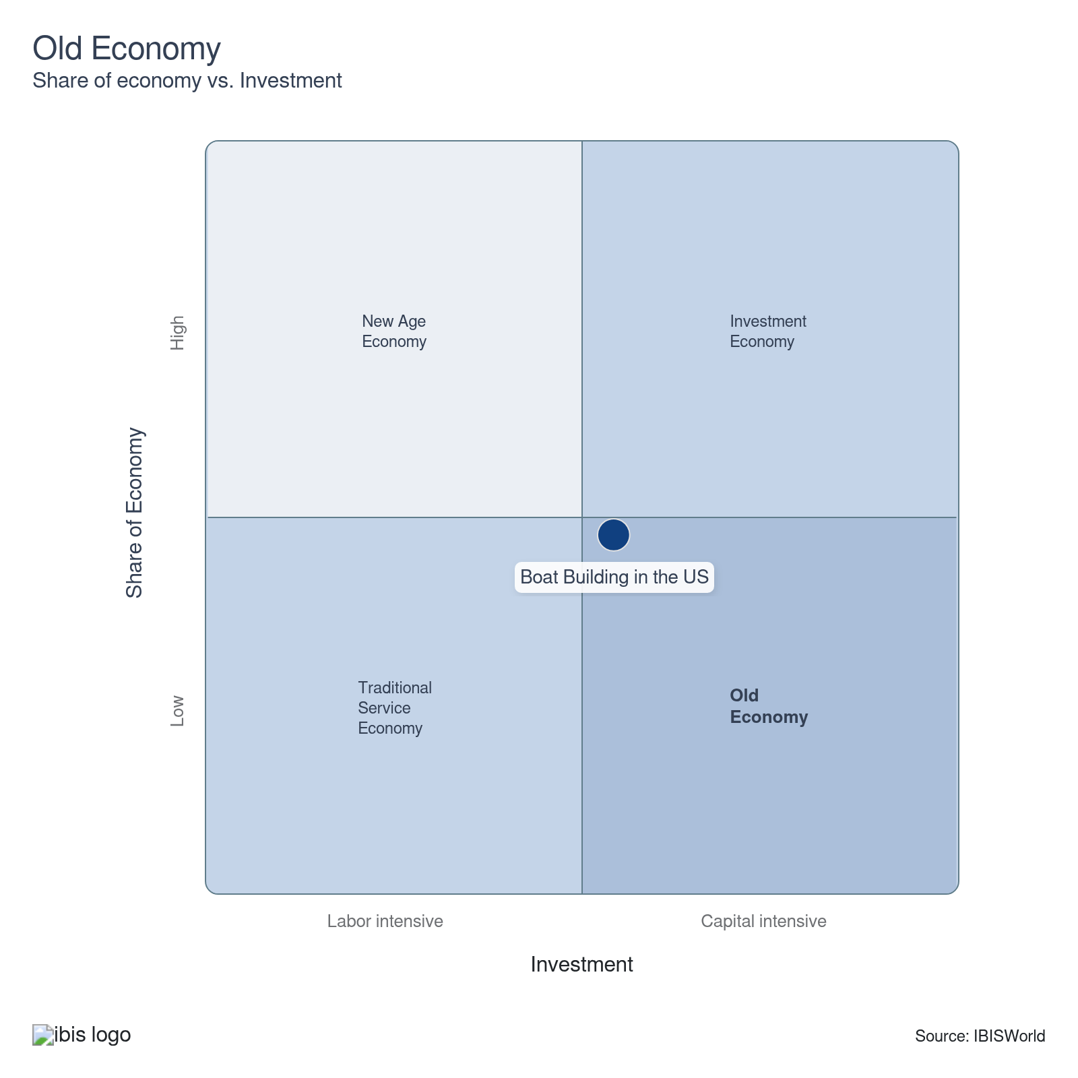

Financial Ratios

Earnings Ratios
Ratio | 2020 | 2021 | 2022 | 2023 | 2024 | 3-Year | 5-Year | 10-Year
EBIT/Revenue | 6.8 | 5.9 | 10.0 | 9.2 | 9.1 | 9.2 | 8.5 | 9.5
EBITDA/Revenue | 9.9 | 9.7 | 14.2 | 14.1 | 13.5 | 13.8 | 12.9 | 13.8
Leverage Ratio | 8.8 | 8.7 | 6.0 | 6.8 | 8.0 | 7.4 | 7.4 | 7.0

Industry Tax Structure
Ratio | 2020 | 2021 | 2022 | 2023 | 2024 | 3-Year | 5-Year | 10-Year
Taxes Paid/Revenue | 1.7 | 1.8 | 2.2 | 1.1 | 1.1 | 1.1 | 1.6 | 2.6

Income Statement
Ratio | 2020 | 2021 | 2022 | 2023 | 2024 | 3-Year | 5-Year | 10-Year
Total Revenue | 100.0 | 100.0 | 100.0 | 100.0 | 100.0 | 100.0 | 100.0 | 100.0
Business receipts | 98.4 | 97.8 | 97.0 | 94.3 | 94.2 | 94.2 | 95.8 | 95.8
Cost of goods | 73.9 | 67.9 | 66.1 | 63.5 | 62.6 | 63.0 | 65.0 | 62.7
Gross Profit | 26.1 | 32.1 | 33.9 | 36.5 | 37.4 | 37.0 | 35.0 | 37.3
Expenses
Salaries and wages | 7.4 | 11.1 | 9.9 | 6.8 | 6.7 | 6.8 | 8.6 | 9.8
Advertising | 0.7 | 1.0 | 1.3 | 0.7 | 0.7 | 0.7 | 0.9 | 1.4
Depreciation | 2.5 | 2.2 | 2.2 | 1.7 | 1.6 | 1.6 | 1.9 | 2.6
Depletion | 0.4 | 0.5 | 0.6 | 0.3 | 0.1 | 0.2 | 0.4 | 0.3
Amortization | 0.3 | 1.1 | 1.5 | 2.9 | 2.7 | 2.8 | 2.0 | 1.4
Rent paid | 1.2 | 1.6 | 1.0 | 1.4 | 1.3 | 1.4 | 1.3 | 1.8
Repairs | 0.6 | 0.8 | 0.9 | 0.4 | 0.3 | 0.3 | 0.6 | 0.5
Bad debts | 0.1 | 0.1 | 0.1 | 0.1 | 0.1 | 0.1 | 0.1 | 0.5
Employee benefit programs | 1.4 | 2.0 | 2.0 | 2.7 | 3.6 | 3.2 | 2.6 | 2.3
Compensation of officers | 1.6 | 2.3 | 1.8 | 5.7 | 5.7 | 5.7 | 3.9 | 3.0
Taxes paid | 1.7 | 1.8 | 2.2 | 1.1 | 1.1 | 1.1 | 1.6 | 2.6
Interest Income | 0.2 | 0.1 | 0.1 | 1.7 | 1.0 | 1.4 | 0.7 | 1.0
Other Income
Royalties | 0.0 | 0.1 | 0.2 | 2.0 | 2.4 | 2.2 | 1.2 | 1.2
Rent Income | 0.2 | 0.9 | 1.2 | 0.6 | 0.3 | 0.5 | 0.8 | 0.5
Net Income | 2.9 | 2.5 | 5.8 | 2.6 | 3.1 | 2.8 | 3.5 | 3.7
Charitable contributions | 0.0 | 0.2 | 0.2 | 0.1 | 0.2 | 0.2 | 0.2 | 0.1
Dividends | 0.3 | 0.0 | 0.1 | 0.3 | 0.6 | 0.4 | 0.2 | 0.2
Interest paid | 2.1 | 1.6 | 1.9 | 5.4 | 4.9 | 5.2 | 3.5 | 3.3
Net gain, noncapital assets | 0.1 | 0.0 | 0.0 | 0.0 | 0.0 | 0.0 | 0.0 | 0.4
Net long-term capital gain less net short-term loss | 0.5 | 0.4 | 0.5 | 0.6 | 0.7 | 0.6 | 0.5 | 0.4
Net loss, noncapital assets | 0.1 | 0.1 | 0.1 | 0.1 | 0.5 | 0.3 | 0.2 | 0.3
Net short-term capital gain less net long-term loss | 0.1 | 0.5 | 0.7 | 0.3 | 0.6 | 0.5 | 0.5 | 0.3
Other deductions | 2.5 | 2.7 | 2.1 | 2.4 | 2.4 | 2.4 | 2.4 | 2.6
Other receipts | 0.2 | 0.2 | 0.2 | 0.2 | 0.2 | 0.2 | 0.2 | 0.2
Pension, profit-sharing, etc., plans | 0.5 | 0.5 | 0.3 | 1.9 | 2.3 | 2.1 | 1.3 | 1.3

Balance Sheet
Ratio | 2020 | 2021 | 2022 | 2023 | 2024 | 3-Year | 5-Year | 10-Year
Assets
Cash and Equivalents | 6.0 | 3.9 | 2.8 | 3.8 | 3.7 | 3.8 | 3.6 | 4.8
Notes and accounts receivable | 4.3 | 9.7 | 22.0 | 8.0 | 10.1 | 9.1 | 12.5 | 10.1
Allowance for bad debts | 0.6 | 0.0 | 0.0 | 1.0 | 1.1 | 1.1 | 0.5 | 0.6
Inventories | 16.6 | 19.9 | 20.4 | 14.7 | 16.9 | 15.8 | 18.0 | 20.8
Other current assets | 1.4 | 1.0 | 0.7 | 4.8 | 5.0 | 4.9 | 2.9 | 3.1
Other investments | 24.7 | 28.8 | 13.7 | 25.3 | 22.5 | 23.9 | 22.6 | 17.2
Property, Plant and Equipment | 13.6 | 10.3 | 16.8 | 12.9 | 17.2 | 15.1 | 14.3 | 20.3
Accumulated depreciation | 8.0 | 3.2 | 9.4 | 5.0 | 7.9 | 6.4 | 6.4 | 11.0
Intangible assets (Amortizable) | 27.9 | 22.0 | 22.3 | 20.1 | 17.6 | 18.8 | 20.5 | 24.4
Accumulated amortization | 1.8 | 9.4 | 9.5 | 4.0 | 3.3 | 3.6 | 6.6 | 4.8
Other assets | 3.6 | 7.4 | 9.2 | 8.1 | 7.8 | 7.9 | 8.1 | 5.4
Total assets | 100.0 | 100.0 | 100.0 | 100.0 | 100.0 | 100.0 | 100.0 | 100.0
Accounts payable | 7.4 | 8.9 | 7.0 | 5.7 | 7.5 | 6.6 | 7.3 | 7.6
Liabilities and Net Worth
Mort, notes, and bonds under 1 yr | 6.6 | 10.8 | 9.7 | 9.2 | 10.0 | 9.6 | 9.9 | 12.0
Other current liabilities | 13.1 | 11.0 | 8.8 | 8.2 | 7.6 | 7.9 | 8.9 | 7.8
Loans from shareholders | 14.0 | 0.2 | 0.1 | 6.2 | 5.9 | 6.0 | 3.1 | 6.4
Mort, notes, bonds, 1 yr or more | 17.3 | 37.9 | 34.0 | 31.2 | 31.5 | 31.3 | 33.6 | 29.1
Other liabilities | 10.7 | 0.9 | 12.1 | 10.0 | 10.3 | 10.1 | 8.3 | 11.2
Total liabilities | 100.0 | 100.0 | 100.0 | 100.0 | 100.0 | 100.0 | 100.0 | 100.0
Capital stock | 10.4 | 2.7 | 0.6 | 1.0 | -0.6 | 0.2 | 0.9 | 4.5
Additional paid-in capital | 15.0 | 20.0 | 22.7 | 30.7 | 24.6 | 27.7 | 24.5 | 19.2
Retained earnings, appropriated | 3.3 | 1.1 | -0.9 | -2.0 | -0.9 | -1.4 | -0.7 | 0.2
Retained earnings-unappropriated | 10.6 | 31.3 | 29.6 | 12.4 | 15.2 | 13.8 | 22.1 | 15.8
Cost of treasury stock | 8.5 | 24.8 | 23.7 | 12.6 | 11.1 | 11.8 | 18.0 | 13.6
Net worth | 30.9 | 30.3 | 28.2 | 29.5 | 27.2 | 28.4 | 28.8 | 26.0
Accumulated depletion | 0.0 | 0.0 | 0.0 | 0.2 | 0.1 | 0.1 | 0.1 | 0.0
Depletable assets | 0.0 | 5.8 | 6.4 | 1.0 | 0.7 | 0.9 | 3.5 | 1.6
Government Obligations | 1.5 | 1.1 | 1.1 | 1.1 | 0.9 | 1.0 | 1.0 | 1.7
Land | 0.3 | 0.8 | 2.0 | 3.3 | 3.0 | 3.1 | 2.3 | 2.5
Loans to shareholders | 4.8 | 0.3 | 0.0 | 0.9 | 1.0 | 1.0 | 0.6 | 1.3
Mortgage and real estate loans | 5.8 | 0.7 | 0.7 | 5.2 | 4.9 | 5.0 | 2.9 | 2.9
Tax Exempt Securities | 0.0 | 0.7 | 0.7 | 1.0 | 0.9 | 0.9 | 0.8 | 0.4

Liquidity Ratios
Ratio | 2020 | 2021 | 2022 | 2023 | 2024 | 3-Year | 5-Year | 10-Year
Current Ratio | 1.1 | 1.2 | 1.9 | 1.5 | 1.5 | 1.5 | 1.5 | 1.5
Quick Ratio | 0.5 | 0.5 | 1.1 | 0.9 | 0.9 | 0.9 | 0.8 | 0.8
Sales/Receivables | 23.5 | 10.3 | 4.6 | 12.5 | 9.9 | 11.2 | 9.3 | 12.4
Days' Receivables | 15.6 | 35.6 | 80.2 | 29.2 | 37.0 | 33.1 | 45.5 | 36.7
Days' Inventory | 71.7 | 90.2 | 95.8 | 80.9 | 105.0 | 93.0 | 93.0 | 117.4
Inventory Turnover | 5.1 | 4.0 | 3.8 | 4.5 | 3.5 | 4.0 | 4.0 | 3.5
Payables Turnover | 11.4 | 9.1 | 11.0 | 11.6 | 7.8 | 9.7 | 9.9 | 9.4
Days' Payables | 32.0 | 40.1 | 33.2 | 31.6 | 46.8 | 39.2 | 37.9 | 42.4
Sales/Working Capital | 23.5 | 14.0 | 4.3 | 8.2 | 7.1 | 7.7 | 8.4 | 1.2

Coverage Ratios
Ratio | 2020 | 2021 | 2022 | 2023 | 2024 | 3-Year | 5-Year | 10-Year
Interest Coverage | 3.2 | 3.6 | 5.2 | 1.7 | 1.8 | 1.8 | 3.1 | 3.3
Debt Service Coverage Ratio | 0.2 | 0.2 | 0.1 | 0.2 | 0.2 | 0.2 | 0.2 | 0.2

Leverage Ratios
Ratio | 2020 | 2021 | 2022 | 2023 | 2024 | 3-Year | 5-Year | 10-Year
Fixed Assets/Net Worth | 1.7 | 1.7 | 2.4 | 1.6 | 1.8 | 1.7 | 1.9 | 2.6
Debt/Net Worth | 3.2 | 3.3 | 3.5 | 3.4 | 3.7 | 3.5 | 3.5 | 3.9
Tangible Net Worth | 30.9 | 30.3 | 28.2 | 29.5 | 27.2 | 28.4 | 28.8 | 26.0

Operating Ratios
Ratio | 2020 | 2021 | 2022 | 2023 | 2024 | 3-Year | 5-Year | 10-Year
Return on Net Worth, % | 25.1 | 23.2 | 41.4 | 32.5 | 31.4 | 32.0 | 32.1 | 41.2
Return on Assets, % | 6.8 | 5.9 | 10.0 | 9.2 | 9.1 | 9.2 | 8.5 | 9.5
Sales/Total Assets | 1.0 | 1.0 | 1.0 | 1.0 | 1.0 | 1.0 | 1.0 | 1.0
EBITDA/Revenue | 9.9 | 9.7 | 14.2 | 14.1 | 13.5 | 13.8 | 12.9 | 13.8
EBIT/Revenue | 6.8 | 5.9 | 10.0 | 9.2 | 9.1 | 9.2 | 8.5 | 9.5

Cash Flow & Debt Service Ratios (% of sales)
Ratio | 2020 | 2021 | 2022 | 2023 | 2024 | 3-Year | 5-Year | 10-Year
Cash from Trading | 26.4 | 33.4 | 46.2 | 26.4 | 33.0 | 29.7 | 34.7 | 37.7
Cash after Operations | 13.0 | 15.3 | 30.3 | 7.7 | 17.8 | 12.7 | 17.8 | 19.5
Net Cash after Operations | 14.3 | 16.6 | 31.2 | 9.8 | 20.3 | 15.0 | 19.4 | 20.4
Debt Service P&I Coverage | 1.6 | 1.3 | 2.8 | 0.6 | 1.2 | 0.9 | 1.5 | 1.3
Interest Coverage (Operating Cash) | 6.7 | 10.1 | 16.4 | 1.8 | 4.1 | 3.0 | 8.1 | 7.3

Valuation Multiples

Valuation Multiples
Ratio | 2020 | 2021 | 2022 | 2023 | 2024 | 3-Year | 5-Year | 10-Year
EV/Revenue | 0.7 | 0.7 | 0.7 | 0.7 | 0.7 | 0.7 | 0.7 | 0.7
EV/EBITDA | 1.9 | 2.6 | 2.4 | 2.6 | 2.4 | 2.5 | 2.4 | 2.1
EV/EBIT | 2.4 | 3.8 | 3.5 | 3.9 | 3.4 | 3.6 | 3.4 | 2.9

Key Ratios
Year | Revenue per Employee  ($) | Revenue per Enterprise  ($ Million) | Employees per Estab.  (Units) | Employees per Enterprise  (Units) | Average Wage  ($) | Wages/ Revenue  (%) | Estab. per Enterprise  (Units) | IVA/ Revenue  (%) | Imports/ Demand  (%) | Exports/ Revenue  (%)
2005 | 316,830 | 16.1 | 48.1 | 50.9 | 51,758 | 16.3 | 1.1 | 16.8 | 12.2 | 14.2
2006 | 325,667 | 16.6 | 48.1 | 50.9 | 52,914 | 16.2 | 1.1 | 16.1 | 12.6 | 15.1
2007 | 314,766 | 15.7 | 46.9 | 49.8 | 52,730 | 16.8 | 1.1 | 18.4 | 13.9 | 19.8
2008 | 306,240 | 13.0 | 40.2 | 42.5 | 53,768 | 17.6 | 1.1 | 16.1 | 15.0 | 26.7
2009 | 303,044 | 8.7 | 27.4 | 28.8 | 55,370 | 18.3 | 1.1 | 18.5 | 16.1 | 26.3
2010 | 360,116 | 9.2 | 24.5 | 25.5 | 59,920 | 16.6 | 1.0 | 23.2 | 16.6 | 31.8
2011 | 376,771 | 10.6 | 27.1 | 28.3 | 58,415 | 15.5 | 1.0 | 21.7 | 17.6 | 28.3
2012 | 355,097 | 11.9 | 32.2 | 33.6 | 57,187 | 16.1 | 1.0 | 22.4 | 12.0 | 14.9
2013 | 384,618 | 13.6 | 33.9 | 35.3 | 58,128 | 15.1 | 1.0 | 21.1 | 12.0 | 14.0
2014 | 392,627 | 14.3 | 35.1 | 36.5 | 57,341 | 14.6 | 1.0 | 20.8 | 11.3 | 12.8
2015 | 402,502 | 15.4 | 36.6 | 38.3 | 59,003 | 14.7 | 1.0 | 21.7 | 15.5 | 9.4
2016 | 361,682 | 16.0 | 42.4 | 44.4 | 57,524 | 15.9 | 1.0 | 23.1 | 13.6 | 7.5
2017 | 382,372 | 16.0 | 39.8 | 41.8 | 60,930 | 15.9 | 1.1 | 22.5 | 14.2 | 8.4
2018 | 381,191 | 16.9 | 42.2 | 44.3 | 61,315 | 16.1 | 1.1 | 21.4 | 12.7 | 9.2
2019 | 371,675 | 15.7 | 40.2 | 42.1 | 62,235 | 16.7 | 1.0 | 22.5 | 14.2 | 10.4
2020 | 370,874 | 15.5 | 39.7 | 41.9 | 61,288 | 16.5 | 1.1 | 21.1 | 15.0 | 7.5
2021 | 389,369 | 18.5 | 45.0 | 47.5 | 63,242 | 16.2 | 1.1 | 21.9 | 15.4 | 9.6
2022 | 376,628 | 22.0 | 54.6 | 58.4 | 60,197 | 16.0 | 1.1 | 21.7 | 17.3 | 10.5
2023 | 393,529 | 22.0 | 52.3 | 55.9 | 60,241 | 15.3 | 1.1 | 20.8 | 17.9 | 10.4
2024 | 457,329 | 22.0 | 44.9 | 48.0 | 61,493 | 13.4 | 1.1 | 18.1 | 15.7 | 10.0
2025 | 488,980 | 21.7 | 41.6 | 44.4 | 63,174 | 12.9 | 1.1 | 15.3 | 10.8 | 7.4
2026 | 486,582 | 21.5 | 41.4 | 44.3 | 63,110 | 13.0 | 1.1 | 16.3 | 10.6 | 7.6
2027 | 484,977 | 21.5 | 41.5 | 44.3 | 63,068 | 13.0 | 1.1 | 16.8 | 10.6 | 7.5
2028 | 483,124 | 21.4 | 41.5 | 44.4 | 63,020 | 13.0 | 1.1 | 16.7 | 10.7 | 7.5
2029 | 483,340 | 21.4 | 41.4 | 44.3 | 63,027 | 13.0 | 1.1 | 16.7 | 10.7 | 7.5
2030 | 486,720 | 21.4 | 41.1 | 44.0 | 63,115 | 13.0 | 1.1 | 16.6 | 10.7 | 7.5
2031 | 490,197 | 21.4 | 40.9 | 43.7 | 63,203 | 12.9 | 1.1 | 16.5 | 10.7 | 7.5
2032 | 491,649 | 21.4 | 40.8 | 43.6 | 63,241 | 12.9 | 1.1 | 16.5 | 10.7 | 7.5
*Figures are inflation adjusted to 2026
*Figures are inflation adjusted to 2026

10. Key Statistics
https://my.ibisworld.com/us/en/industry/33661b/key-statistics

Industry Data

Values
Year | Revenue  ($ Million) | IVA  ($ Million) | Estab.  (Units) | Enterprises  (Units) | Employment  (Units) | Exports  ($ Million) | Imports  ($ Million) | Wages  ($ Million)
2005 | 17,641.4 | 2,971.9 | 1,157 | 1,094 | 55,681 | 2,497.0 | 2,103.5 | 2,881.9
2006 | 17,684.4 | 2,844.8 | 1,129 | 1,066 | 54,302 | 2,678.8 | 2,163.4 | 2,873.4
2007 | 16,730.8 | 3,073.5 | 1,133 | 1,067 | 53,153 | 3,308.3 | 2,164.5 | 2,802.7
2008 | 13,562.8 | 2,178.9 | 1,103 | 1,042 | 44,288 | 3,621.0 | 1,760.6 | 2,381.3
2009 | 8,028.8 | 1,488.9 | 966 | 919 | 26,494 | 2,113.3 | 1,136.7 | 1,467.0
2010 | 7,981.2 | 1,848.4 | 906 | 868 | 22,163 | 2,541.1 | 1,084.8 | 1,328.0
2011 | 8,794.6 | 1,908.4 | 860 | 826 | 23,342 | 2,485.0 | 1,344.3 | 1,363.5
2012 | 9,971.5 | 2,234.5 | 871 | 836 | 28,081 | 1,482.9 | 1,158.5 | 1,605.9
2013 | 10,845.8 | 2,290.0 | 831 | 799 | 28,199 | 1,513.8 | 1,268.0 | 1,639.2
2014 | 11,643.7 | 2,419.9 | 846 | 812 | 29,656 | 1,487.5 | 1,292.3 | 1,700.5
2015 | 12,781.0 | 2,771.0 | 867 | 829 | 31,754 | 1,199.4 | 2,123.6 | 1,873.6
2016 | 12,947.9 | 2,995.6 | 844 | 807 | 35,799 | 975.7 | 1,888.2 | 2,059.3
2017 | 13,319.2 | 3,003.0 | 875 | 833 | 34,833 | 1,117.9 | 2,025.0 | 2,122.4
2018 | 14,382.3 | 3,079.0 | 894 | 851 | 37,730 | 1,318.9 | 1,901.1 | 2,313.4
2019 | 13,330.5 | 3,000.1 | 892 | 851 | 35,866 | 1,382.8 | 1,969.4 | 2,232.1
2020 | 13,013.6 | 2,745.6 | 883 | 837 | 35,089 | 981.8 | 2,118.1 | 2,150.5
2021 | 15,672.9 | 3,434.9 | 895 | 848 | 40,252 | 1,500.2 | 2,571.9 | 2,545.6
2022 | 18,584.7 | 4,029.7 | 903 | 845 | 49,345 | 1,959.3 | 3,481.6 | 2,970.4
2023 | 19,149.9 | 3,984.0 | 930 | 870 | 48,662 | 1,991.9 | 3,733.8 | 2,931.4
2024 | 19,349.1 | 3,511.1 | 942 | 881 | 42,309 | 1,931.7 | 3,253.5 | 2,601.7
2025 | 19,199.8 | 2,941.2 | 945 | 884 | 39,265 | 1,428.7 | 2,147.7 | 2,480.5
2026 | 19,111.0 | 3,105.7 | 948 | 887 | 39,276 | 1,443.0 | 2,100.3 | 2,478.7
2027 | 19,205.1 | 3,218.8 | 954 | 893 | 39,600 | 1,447.6 | 2,115.0 | 2,497.5
2028 | 19,338.0 | 3,232.7 | 964 | 902 | 40,027 | 1,456.6 | 2,131.5 | 2,522.5
2029 | 19,492.6 | 3,246.9 | 973 | 910 | 40,329 | 1,467.2 | 2,150.3 | 2,541.8
2030 | 19,666.9 | 3,260.5 | 982 | 919 | 40,407 | 1,479.3 | 2,171.3 | 2,550.3
2031 | 19,861.3 | 3,283.9 | 991 | 927 | 40,517 | 1,492.9 | 2,194.6 | 2,560.8
2032 | 20,028.8 | 3,310.4 | 999 | 935 | 40,738 | 1,504.4 | 2,215.0 | 2,576.3

*Figures are inflation adjusted to 2026

Annual Change
Year | Revenue  % | IVA  % | Estab.  % | Enterprises  % | Employment  % | Exports  % | Imports  % | Wages  %
2005 | N/A | N/A | N/A | N/A | N/A | N/A | N/A | N/A
2006 | 0.2 | -4.3 | -2.4 | -2.6 | -2.5 | 7.3 | 2.8 | -0.3
2007 | -5.4 | 8.0 | 0.4 | 0.1 | -2.1 | 23.5 | 0.1 | -2.5
2008 | -18.9 | -29.1 | -2.6 | -2.3 | -16.7 | 9.4 | -18.7 | -15.0
2009 | -40.8 | -31.7 | -12.4 | -11.8 | -40.2 | -41.6 | -35.4 | -38.4
2010 | -0.6 | 24.1 | -6.2 | -5.5 | -16.3 | 20.2 | -4.6 | -9.5
2011 | 10.2 | 3.2 | -5.1 | -4.8 | 5.3 | -2.2 | 23.9 | 2.7
2012 | 13.4 | 17.1 | 1.3 | 1.2 | 20.3 | -40.3 | -13.8 | 17.8
2013 | 8.8 | 2.5 | -4.6 | -4.4 | 0.4 | 2.1 | 9.5 | 2.1
2014 | 7.4 | 5.7 | 1.8 | 1.6 | 5.2 | -1.7 | 1.9 | 3.7
2015 | 9.8 | 14.5 | 2.5 | 2.1 | 7.1 | -19.4 | 64.3 | 10.2
2016 | 1.3 | 8.1 | -2.7 | -2.7 | 12.7 | -18.6 | -11.1 | 9.9
2017 | 2.9 | 0.2 | 3.7 | 3.2 | -2.7 | 14.6 | 7.2 | 3.1
2018 | 8.0 | 2.5 | 2.2 | 2.2 | 8.3 | 18.0 | -6.1 | 9.0
2019 | -7.3 | -2.6 | -0.2 | 0.0 | -4.9 | 4.8 | 3.6 | -3.5
2020 | -2.4 | -8.5 | -1.0 | -1.6 | -2.2 | -29.0 | 7.6 | -3.7
2021 | 20.4 | 25.1 | 1.4 | 1.3 | 14.7 | 52.8 | 21.4 | 18.4
2022 | 18.6 | 17.3 | 0.9 | -0.4 | 22.6 | 30.6 | 35.4 | 16.7
2023 | 3.0 | -1.1 | 3.0 | 3.0 | -1.4 | 1.7 | 7.2 | -1.3
2024 | 1.0 | -11.9 | 1.3 | 1.3 | -13.1 | -3.0 | -12.9 | -11.2
2025 | -0.8 | -16.2 | 0.3 | 0.3 | -7.2 | -26.0 | -34.0 | -4.7
2026 | -0.5 | 5.6 | 0.3 | 0.3 | 0.0 | 1.0 | -2.2 | -0.1
2027 | 0.5 | 3.6 | 0.6 | 0.7 | 0.8 | 0.3 | 0.7 | 0.8
2028 | 0.7 | 0.4 | 1.0 | 1.0 | 1.1 | 0.6 | 0.8 | 1.0
2029 | 0.8 | 0.4 | 0.9 | 0.9 | 0.8 | 0.7 | 0.9 | 0.8
2030 | 0.9 | 0.4 | 0.9 | 1.0 | 0.2 | 0.8 | 1.0 | 0.3
2031 | 1.0 | 0.7 | 0.9 | 0.9 | 0.3 | 0.9 | 1.1 | 0.4
2032 | 0.8 | 0.8 | 0.8 | 0.9 | 0.5 | 0.8 | 0.9 | 0.6

*Figures are inflation adjusted to 2026

DISCLAIMER
This product has been supplied by IBISWorld Inc. (‘IBISWorld’) solely for use by its authorized licenses strictly in accordance with their license agreements with IBISWorld. IBISWorld makes no representation to any other person with regard to the completeness or accuracy of the data or information contained herein, and it accepts no responsibility and disclaims all liability (save for liability which cannot be lawfully disclaimed) for loss or damage whatsoever suffered or incurred by any other person resulting from the use of, or reliance upon, the data or information contained herein. Copyright in this publication is owned by IBISWorld Inc. The publication is sold on the basis that the purchaser agrees not to copy the material contained within it for other than the purchasers own purposes. In the event that the purchaser uses or quotes from the material in this publication – in papers, reports, or opinions prepared for any other person – it is agreed that it will be sourced to: IBISWorld Inc.

